**UNIVERSITY OF COLORADO DENVER (CU-D) ANSCHUTZ MEDICAL CAMPUS**

The UCD Anschutz Medical Campus(AMC) is the largest academic health center in the Rocky Mountain region which brings together on the same campus for the first time three hospitals and educational, administrative, and research facilities for all six health science schools of **CU-D**. The 11.3 million ft2 of state-of-the-art facilities has benefited from over $4 billion of investments to date. The 230 acre campus provides adjacencies of clinical, educational, and research facilities all within walking distance of each other, building a new culture of collaboration among clinicians, investigators, and educators that invigorates research and innovation. An adjacent biotechnology park helps facilitate close collaboration between University investigators, industry, and the private sector.

**COLORADO CLINICAL AND TRANSLATIONAL SCIENCES INSTITUTE**

The Colorado Clinical and Translational Sciences Institute (CCTSI) was established in 2008 with funding from the Clinical and Translational Science Award (CTSA) initiative of the National Institutes of Health (NIH) and substantial support from the involved institutions. It is a collaborative organization which aims to transform existing clinical and translational research and training efforts into a shared research enterprise. The **Vision of the CCTSI** is to accelerate and catalyze the translation of innovative science into improved health and patient care. To achieve this vision, the **Mission of the CCTSI** is to:

* + Catalyze and enhance scientific discovery, innovation, dissemination and translation across the lifespan
  + Educate and sustain a resilient, innovative and diverse translational science workforce
  + Promote and ensure an efficient, safe, collaborative and integrated research environment
  + Engage stakeholders and communities across the entire translational spectrum (T05. to T4; Figure 1).

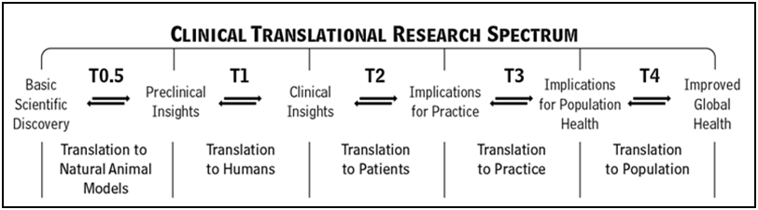

**Figure 1. Spectrum of Clinical and Translational research**

The CCTSI is an Institute within the University of Colorado, based at University of Colorado Denver Anschutz Medical Campus (CU-AMC). As such, CCTSI Program Directors and staff are generally housed within their home department, according to faculty affiliation. The Institute’s resources, therefore, are distributed across the schools, campuses, and affiliated hospital that is serves. These include 5 Clinical Translational Research Centers (CTRCs) providing inpatient and outpatient clinical research resources at University of Colorado Hospital (UCH), Children’s Hospital Colorado (CHCO), National Jewish Health (NJH), and CU-Boulder with an additional mobile perinatal CTRC; contact points at each hospital; and programs located across the AMC, downtown campus, our affiliated institutions across Colorado, and the hospitals. The CCTSI provides office space for administrative staff in the Leprino Office Building, located between the University of Colorado Hospital and the University of Colorado Denver. This space also houses conference rooms and open workspaces that allow CCTSI Program Directors and staff to collaborate and work together.

An Executive Committee, chaired by the CCTSI Director and Principal Investigator, Ronald J. Sokol, MD, oversees operations and decision making. Dr. Sokol reports to the Vice Chancellors for Research and the Vice Chancellor for Health Affairs (the Dean of the School of Medicine) of CU-D, who in turn report to the Chancellor of CU-D. The CCTSI involves the 6 health professional schools and colleges located at the CU-D AMC; the Schools of Engineering and Applied Science, Liberal Arts and Science, and Education and Human Development of CU-D Downtown Campus; the Colleges of Arts and Sciences and of Engineering and Applied Science at University of Colorado, Boulder; and the colleges of Veterinary Medicine and Biomedical Sciences, Liberal Arts, Health and Human Services, and Engineering at Colorado State University. Affiliated institutions include 6 local hospitals and health care organizations: University of Colorado Hospital (UCH), Children’s Hospital Colorado (CHCO), Denver Health (DH), National Jewish Health (NJH), Denver Veterans Affairs Medical Center (DVAMC), and Kaiser Permanente of Colorado (KP). Faculty, trainees, and research staff at each of these institutions may become CCTSI members to access CCTSI resources. Through the CCTSI’s Partnership of Academicians and Communities for Translation (PACT), our community engagement and research program, it has 18 established Community-Academic partnerships throughout Colorado, involving diverse and underserved populations throughout the state. This collaborative network of universities, hospitals, and the communities they serve have successfully promoted excellence in health care professional training and cutting-edge research programs and innovation for the past 30 years. Investigators from all areas of biomedical, biobehavioral and health services research use the CCTSI to access resources for innovative interdisciplinary research and clinical and translational sciences training. The CCTSI requires membership of faculty, research associates and post-Docs, trainees, community members, private companies, and public entities in order to use CCTSI resources, training programs or facilities. In April 2017, we had 4,200 members.

**Overall Organization and Governance**

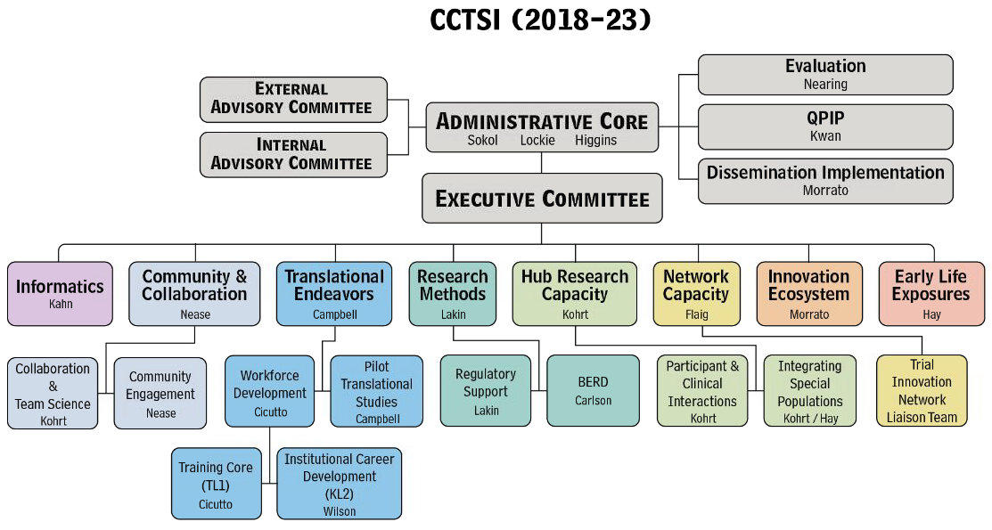

**CCTSI PROGRAMS AND RESOURCES**

**Administrative Core Organizational Chart**

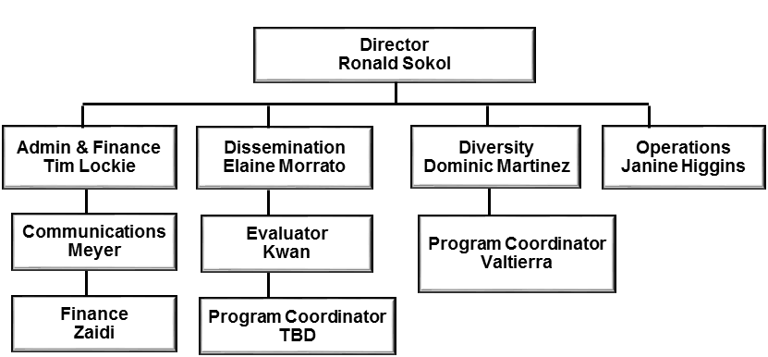

**Biostatistics, Epidemiology, and Research Design (BERD) Core**

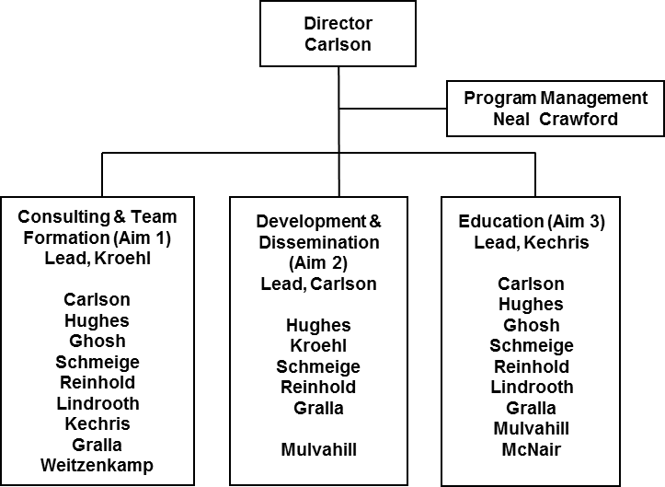The BERD Core allows CCTSI members to collaborate and consult with biostatisticians who can assist with study design, grant writing and planning of biostatistical analysis. The actual analysis of data is not funded by CTSA grant funds, but rather from funding of individual research grants and studies. The one exception is for Junior investigators without substantial grant support, who can apply for CCTSI *Microgrants* that can offset some of the costs of the statistical analysis. BERD provides innovative training programs in biostatistics for non-statisticians. As part of the Colorado School of Public Health (CSPH), whose core mission is to promote the physical, mental, social and environmental health of people and communities in the Rocky Mountain Region and globally, BERD leverages and integrates CSPH and CCTSI resources.

# Computer

The CSPH at the University of Colorado Denver is equipped with over 160 computers and work stations. CSPH faculty have computers and laser printers for their use. University computing facilities provide access to e-mail, Internet, and bibliographic databases. Information technology specialists are available on a fee-for-service basis through the CU Denver Workstation Support Center. The institution has also invested in a high performance computer network, Rosalind. This is available on a fee-per core hour used. Rosalind is composed of 768 cores, 4 TB of RAM (128 GB RAM per node), 3.7 PB of usable storage and a high memory node with 1.5 TB of RAM. This in-house, comprehensive, stand-alone biocomputing unit supports a multidisciplinary, robust computing resource to foster omics-based research using high-dimensionality data (e.g. genomics, transcriptomics, microbiomics, proteomics, metabolomics) and development and implementation of computational methods and tools for sequence analysis and systems biology approaches.​. To conduct rigorous and reproducible analyses, the Colorado Biostatistics Consortium and Department of Biostatistics and Informatics of the CSPH will conduct statistical analyses for larger projects.

# Office

BERD space is primarily located within the CSPH in Buildings 500 and 406 on the Anschutz Medial Campus. Building 500 comprises 25,410 square feet of state-of-the-art office space with Building 406 providing more than 30 additional offices. The school provides basic furniture, fax machines, copiers, and non-research related office supplies. In addition, the CSPH facility provides meeting and conference rooms, with video conferencing capabilities, that can be scheduled for project use as needed. The Colorado Biostatistics Consortium and the BERD (which shares office space with the Colorado Biostatistics Consortium) have individual offices in Building 406 for 10 of the faculty members. Building 500 provides an individual office for 5 of the other faculty members in their respective Departments. The project managers in the BERD are housed in Building 406 adjacent to the Director (Dr. Nichole Carlson).

# Scientific Environment

In July 1, 2008, the newly established CSPH was the first and only school of public health in the Rocky Mountain Region, attracting top tier faculty and students from across the county, and providing a vital contribution toward ensuring our region’s health and well-being. Collaboratively formed by the University of Colorado Denver, Colorado State University and the University of Northern Colorado, CSPH provides training, innovative research and community service to actively address public health issues, including chronic disease, access to health care, environmental threats, emerging infectious disease, and costly injuries.

# Colorado Biostatistics Consortium (CBC)

The CBC is a campus wide resource for establishing and supporting collaborative and consulting relationships with clinical and health researchers, primarily at the Anschutz Medical Campus. The CBC resides in the Department of Biostatistics and Informatics of the CSPH and has 10 PhD faculty, three MS faculty, and several graduate student research assistants. All have academic appointments in the Department of Biostatistics and Informatics and a subset of the faculty and MS participate in the BERD. The range of expertise is substantial and varied. Some areas include: Bayesian modeling, clinical trials, causal inference, spatial modeling, SEM and mediation analyses, microbiome, and ‘omics (RNAseq, methylation, proteomics, metabolomics among others).

**Clinical Translational Research Centers (CTRCs)**

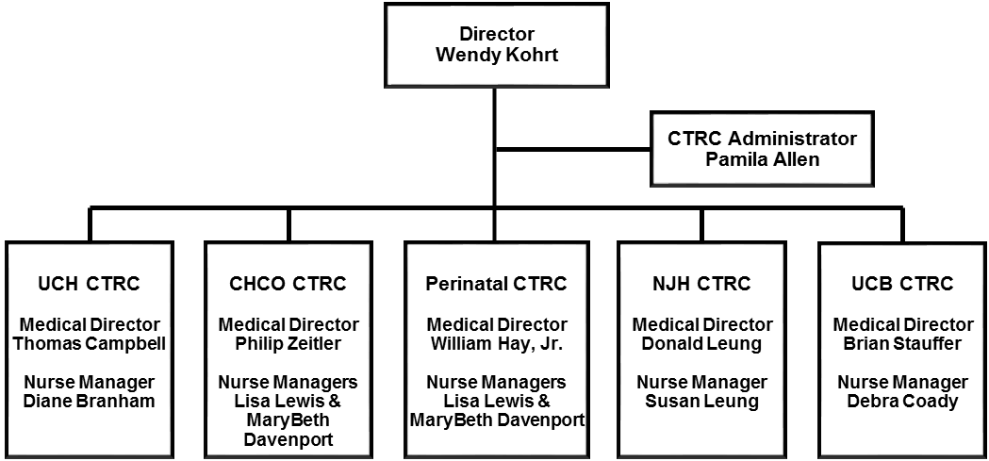Our network of 5 Clinical Translational Research Centers (CTRCs; our clinical research units) provides inpatient and outpatient research facilities. The CTRCs have their original foundation in the enormously effective Adult and Pediatric GCRC facilities, which were continuously NIH-funded for 46 and 45 years, respectively, before the NIH transitioned the GCRC grant program to its CTSA initiative. The CTRCs have been transformed since this transition and now provide resources for all phases of clinical trial development and conduct, critical care (adult and pediatric), and expanded multidisciplinary coordinated clinical research support. CTRC facilities are provided at University of Colorado Anschutz Medical Campus (UCH and CHCO), University of Colorado Boulder, National Jewish Health, and a mobile perinatal unit at several hospitals. Available CTRC resources include dedicated inpatient and outpatient research space and equipment, expert research nursing, Core laboratories, and nutrition services. An additional mobile Perinatal CTRC operates at UCH, CHCO and Denver Health to facilitate research in pregnant women and newborns. All CTRC services are available to investigators on a fee-for-service basis, since 2015.

**Anschutz Medical Campus (AMC)**

***University of Colorado Hospital (UCH) CTRC***

**Facility**

The UCH CTRC provides the space, staff, and equipment necessary to conduct a broad range of specialized research procedures in primarily adults, including measurement of insulin sensitivity (insulin and glucose clamps, OGTT, IVGTT), body composition measurements, medication administration and infusions, bronchoscopies, fat and muscle biopsies, VO2max and graded exercise tests, echocardiography for vascular and cardiac studies, sleep studies (acute and chronic) with polysomnography, measurement of total energy expenditure and rates of macronutrient utilization, conduct of short- and long-term exercise and dietary intervention studies, and specimen collection and processing. All procedures are supervised by highly-qualified and experienced personnel. All staff receive HIPAA and Good Clinical Practice training. Nurses are Basic Life Support (BLS), Advanced Cardiac Life Support (ACLS), and ONS (Chemotherapy) certified. Health technicians are BLS certified.

The UCH CTRC has 7,226 sq ft of inpatient space located on the 12th floor of UCH at the Anschutz Medical Campus, has seven beds in five rooms, and a wet lab for sample processing. Additional unique resources include an inpatient whole room calorimeter for the measurement of 24-hour energy expenditure and substrate oxidation, and a sleep laboratory with adjacent monitoring space for polysomnography. Experienced research nursing and health technician support is available.

The UCH outpatient CTRC consists of 6,000 sq ft of space, which houses an outpatient research clinic. Facilities in the clinic include an infusion room (5 chairs), phlebotomy room (5 stations), exercise testing room (3 stations), muscle function room (isokinetic dynamometer), body composition room (DXA, pQCT), secure medication storage room (approved for FDA controlled substances, including Schedule 1), sample processing room, negative pressure room, 2 interview rooms, 2 large procedure rooms with beds, 4 small procedure rooms with beds (including one for RMR and one for echosonography), and 8 exam rooms with exam tables. There is a charting/work area with 5 computer work stations that can be used by research team members. An adjacent 3,200 sq ft state-of-the-art research exercise training facility is available for exercise intervention research. The CTRC also includes a Bionutrition core, special metabolic kitchen, and a core laboratory. The CTRC clinical outpatient facility is generally open weekdays 7am – 6pm. During these hours, experienced physician assistant, research nursing, health technician, laboratory, and nutrition support is available. Outpatient visits that occur outside of regular opening hours can sometimes be accommodated by inpatient CTRC nursing staff.

The UCH CTRC has 11.4 FTE of research nurses, 1.5 FTE of health technician support, a 1.0 FTE sonographer (shared between UCH and CHCO CTRCs), a 1.0 FTE physician assistant, 0.3 FTE DXA technician, 4.4 FTE of nutrition and metabolic kitchen staff, and 3.6 FTE of core laboratory staff support. These research professionals have extensive experience in conducting and documenting research for a diverse patient population from 12 to 90 years of age, both healthy and with a range of diseases such as diabetes, obesity, cardiovascular disease, renal disease, COPD, HIV and AIDS, chronic viral hepatitis, various forms of cancer, alcoholism, etc.

**Equipment**

* Portable indirect calorimetry (IC): True Max 2400 and TrueOne 2400 Metabolic Measurement Systems (Parvo Medics, Sandy UT), Ultima CPX 5530 (Medgraphics Corp, Saint Paul, MN)
* Maximal and submaximal exercise testing: Corival Ergometer and Lodebike 906900 (Lode Holding Company, Groningen The Netherlands), Velotron Pro exercise bike (RacerMate Inc, Seattle WA)
* Body composition measurement (Dual X-ray Absorptiometer): Discovery W (Hologic, Marlborough, MA)
* Stress Testing: Quinton Q-Stress Cardiac Stress Testing System with treadmill (Mortara, Milwaukee WI)
* CSMi Humac Norm isokinetic dynamometer (Computer Sports Medicine Inc, Stoughton, MA)
* Whole Room Calorimeter: CO2 Analyzer AO2000 System (ABB Inc, Wickliffe OH), differential O2 Analyzer Sable FC-2, Oxygen Analyzer (Sable Systems, Las Vegas, NV), Oxymat 6 Gas Analyzer (Siemens, Washington DC)
* Peripheral Quantitative Computed Tomography (pQCT): Large Bore Scanner XCT 3000 (Orthometrix Inc, Naples FL)
* Cardiovascular Imaging: Ultrasound Vivid 7 and Vivid E9 (GE Healthcare, Pittsburgh PA)
* Cardiac Monitoring: M8004a Cardiac Monitoring System (Philips , Andover MA)
* Sample Processing: 3 x Algra 6r refrigerated centrifuges (Beckman Coulter, Brea CA)
* Bronchoscopes: 2 x Olympus Airway Mobile Scope MAF Type TM (Olympus America, Center Valley PA), and 2 x Pentax FB-18BS Bronchoscope (Montvale, NJ)

***Children’s Hospital Colorado (CHCO) CTRC***

**Facility**

The CHCO CTRC provides the space, staff, and equipment necessary to conduct a broad range of research procedures in children, including measurement of insulin sensitivity (insulin and glucose clamps, OGTT, IVGTT), body composition measurements, medication administration and infusions, bronchoscopies, fat and muscle biopsies, maximal and submaximal exercise tests, echocardiography for vascular and cardiac studies, measurement of total energy expenditure and rates of macronutrient utilization, and conduct short- and long-term exercise and dietary intervention studies, as well as specimen collection and processing. All procedures are supervised by highly-qualified and experienced personnel. All staff receive HIPAA and Good Clinical Practice training. Nurses are Pediatric and Basic Life Support (BLS) certified. Health technicians are BLS certified.

The CHCO CTRC has up to four inpatient beds located on the 9th floor of CHCO at the Anschutz Medical Campus and an adjacent wet lab for sample processing. The CTRC utilizes this space as needed and, if patient rooms are not being utilized, they are released for hospital use. Experienced research nursing and health technician support is available 24h/d, 4d/wk.

The CHCO outpatient CTRC consists of 5,973 sq ft of space located on the 3rd floor of the outpatient pavilion at CHCO which houses four infusion rooms, six exam rooms, an Echocardiography lab, one treatment room, two consult/consenting rooms, three staff workrooms, a secure medication room, and a wet lab for sample processing. The body composition (DXA) laboratory is located in the Radiology Department on the 1st floor. The CTRC clinical outpatient facility is generally open weekdays 7am – 6pm. During these hours, experienced nurse practitioner, research nursing, health technician, laboratory, and nutrition support is available. Outpatient visits that occur outside of regular opening hours are accommodated by request.

The CHCO CTRC facility has 7.1 FTE of research nurses, 1.0 FTE of health technician support, a 1.0 FTE sonographer (shared between UCH and CHCO CTRCs), 4.4 FTE of nutrition and metabolic kitchen staff, and 5.2 FTE of core laboratory staff support. This core of research professionals has extensive experience in conducting and documenting research for a diverse patient population from birth – 49 years of age, both healthy and with a range of diseases such as type 1 and type 2 diabetes, obesity, cystic fibrosis, cardiovascular disease, chronic hepatitis, rare genetic and metabolic diseases, gastrointestinal disease, cholestatic and fatty liver diseases, HIV, various forms of infectious diseases, etc.

**Equipment**

* Body composition measurement: DXA Discovery A (Hologic, Marlborough, MA), BodPod (COSMED, Concord CA)
* Exercise equipment: Treadmill F85 (Sole, USA), and Ergomatic 828 E (Monark, Vansbro Sweden)
* Sample processing: Allegra X-22R Centrifuge (Beckman Coulter, Brea CA), Allegra X-30R centrifuge (Beckman Coulter, Brea CA), and Heraeus Multifuge 3L-R Centrifuge (Thermo Electron Corporation, Madison WI)
* Sample storage: 60082 refrigerator (Kenmore, Brea CA), GIE21 refrigerator (GE Appliances, Pittsburgh PA), Fridge (U-Line), Freezer (Sanyo), FUF20 Freezer (GE Appliances, Pittsburgh PA)
* Cardiac monitoring: Mac 1200 ECG system (GE Healthcare, Pittsburgh PA)

***Perinatal (PN) CTRC***

**Facility**

The PN CTRC is a mobile nursing service located on the Anschutz Medical Campus to facilitate research in pregnant women and newborns, primarily at University of Colorado and Children’s Hospital Colorado Labor and Delivery (L&D) and Neonatal Intensive Care (NICU) units. This unit facilitates screening, consent, and enrollment of these vulnerable populations as well collecting and processing biological specimens for research. The PN CTRC has 480 sq ft of office and storage space on the 4th floor of the CHCO Administrative Pavilion, directly adjacent to the hospital, and wet lab space for sample processing adjacent to the UCH NICU, within the CHCO NICU, and in the basement of the East Tower at CHCO. All nurses have NICU experience. The PN CTRC is available 24h/7d with staff on call.

The PN CTRC has 4.0 FTE of research nurses and 1.0 FTE of health technician support. This group of professionals has experience conducting research in a broad range of newborns and pregnant women including premature infants and neonates with severe illnesses such as respiratory failure, respiratory distress syndrome, persistent pulmonary hypertension, cardiac disease and extreme prematurity, and pregnant women with pre-eclampsia, premature preterm rupture of membranes, gestational diabetes, obesity, and HIV.

**Equipment**

* Body composition measurement: PEAPOD (COSMED, Concord CA)
* Sample storage: freezers ULT185-5-A33 and 8603 (Forma, Asheville, NC)
* Sample processing: Refrigerated benchtop centrifuges G032 (Beckman Coulter, Palto Alto, CA), and L017 (Beckman Coulter, Germany)

**National Jewish Health (NJH)**

**Facility**

The NJH CTRC provides space, nursing services and core laboratory services for a broad range of research specializing in, but not limited to, Pulmonary, Asthma, Immunology and Allergy for adult and pediatric populations. The unit consists of 4 patient care exam rooms, 1 interview room, and 1 negative air flow room. Two rooms are equipped with oxygen flow meters. There are 593 square feet of dedicated space for patient care use located on the third floor of the Goodman Building and 873 square feet of office space. The unit is staffed by 1.5 RN’s and is supported by a Nurse Practitioner and 1.0FTE of administration/regulatory support. History and Physical Exams, skin biopsies, consenting subjects for studies, spirometry, skin testing, induced sputum, sweat testing, medication administration, 12 Lead EKG, etc. are performed in the unit. The unit works with the Pharmacy for medication storage and distribution.

**Equipment**

* EKG machine: ELI380 (Mortara Instrument, Inc., Milwaukee, WI) and MAC5500 CLR STD ENG NA AHA, (GE Medical Systems Information Technologies, Wauwatosa, WI)
* Spirometry: 2 x MCG Diagnostics (Breeze Suite version 8.1) (Medgraphics Corp, Saint Paul, MN)

**University of Colorado Boulder (CU-B)**

**Facility**

The CU-B Clinical and Translational Research Center is the only active NIH-funded CTRC

Facility not located at a clinical institution in the U.S. It is an AAAHC-approved health care facility with 4,000 sq ft of dedicated CTRC space on the 3rd of the Wardenburg Health Center at the Boulder Campus. The facility includes 5 outpatient research protocol rooms (one is a Faraday cage which facilitates structured, not electrical, interference), an exercise testing/indirect calorimetry room, a body composition (DEXA) laboratory, a nutritional consultation room and a wet laboratory for processing blood and tissues. The CTRC has 1.25 FTE staff physician coverage (funded in the past by the Chancellor’s Office at CU-Boulder), 3.0 FTE research nurse support, an Integrative Physiology Core Laboratory with 1.2 FTE personnel support, a 0.5 FTE bionutritionist, and a 1.0 FTE medical technician. There is an on-call nurse and physician available in the evenings 7 days/week to respond to research participant needs/concerns.

**Equipment**

* Cardiovascular Imaging: Xario XG multi-specialty ultrasound imaging system (Toshiba America Medical Systems, Inc., Tustin, CA) with high resolution (7.5 and 12 MHz) linear array transducers
* WinDaq data acquisition software (Dataq Instruments, Akron, OH)
* Vascular Imaging Acquisition and Analysis: Vascular Analysis Tools software version 5.10.9 (Medical Imaging Applications, LLC, Coralville, IA) equipped with Top Performance Analysis Integrated System with imager and frame grabber (DICOM, Rosslyn, VA), vascular ECG-gating module (University of Iowa, Iowa City, IA) and MIA Vascular Research Tools 5 analysis software
* Forearm Cuff Occlusion: E20 Inflator AG101 Air Source, Rapid Version Cuffs (Hokanson, Inc., Bellevue, WA)
* Infusion pumps for saline and vitamin C: Imed Gemini PC-2TX (Alaris Medical Systems, San Diego, CA)
* Arterial Blood Pressure and ECG: Recording system with pressure transducer and ECG amplifiers (Gould ACQ-16, Gould Instruments, Valley View, OH)
* Semi-Automated Resting Blood Pressure Measurements: Datascope Accutorr V (Mindray DS USA, Inc., Mahwah, NJ)
* Ankle-Brachial Index: Transcutaneous Doppler flowmeters 810-A, (Parks Medical, Aloha, OR)
* Body Composition Analysis: Lunar Prodigy Dual Energy X-ray Absorptiometry (DEXA) system and

encore analysis software version 15 (GE Medical Systems, Madison, WI)

* Nutritional Analysis: Nutrition Data System for Research (NDSR; Nutrition Coordinating Center, University of Minnesota)
* Exercise Testing: Ultima gas analyzer module with ECG interface (MedGraphics, Saint Paul, MN), BreezeSuite ventilatory data collection software version 7.2C (MedGraphics, Saint Paul, MN), Trackmaster 425 Treadmill and 12-lead ECG-treadmill interface (Full Vision Inc., Newton KS)

**CTRC Core Laboratories**

**Facilities**

CTRC Core Laboratories are located at UCH, CHCO, and NJH. The CHCO Core Laboratory is 10,000sq ft of space located in the basement of CHCO, adjacent to the hospital’s clinical laboratory. The UCH Core Laboratory is 1,600 sq ft located within the UCH CTRC outpatient space on the third floor of the Leprino Building. The NJH Core Laboratory is 300 sq ft located in the Goodman Building. All laboratories are College of American Pathologists (CAP)- and Clinical Laboratory Improvement Amendments (CLIA)-accredited and provide trained personnel, reagents, equipment, and QC capabilities to conduct over 250 specialized assays for research (full list at <http://www.ucdenver.edu/research/CCTSI/programs-services/ctrc/lab-services/Pages/Lab-Assays-Pricing.aspx>). There is no redundancy in the services offered by the CCTSI Core Laboratory Network: the UCH Core lab specializes in hormone and metabolite assays (3.6FTE); CHCO Core Laboratory focuses on inflammation markers, fat-soluble vitamin measurement, specific protein and pulmonary fluid processing (5.2 FTE); and NJH Core lab specializes in flow cytometry, specialized cell culture, and DNA and RNA extraction (1.0 FTE).

**Equipment**

* Cold Sample Storage: Freezer Forma 923, Ultracold Forma 983, 4 x Ultracold Forma 995, 6 x Thermo Forma 8000 series , Thermo Electron, Forma 989 Dd , 2 x Panasonic -80C (Panasonic Healthcare Corporation of North America, Wood Dale IL), Forma Ultra 990, Undercounter 3.6ºC Isotemp (ThermoFisher Scientific, Waltham MA); Ultra 500BX (Sanyo, San Diego CA)
* Centrifuges: 6 x Allegra 6r, Allegra X-15R, Avanti 30, Avanti J-20 (Beckman Coulter, Brea CA); Sorvall Lengend RT and RT6000D, RC3B Plus (ThermoFisher Scientific, Waltham MA); 2 x Eppendorf 5702R (Westbury, NY), 2 x Centra CL3R (Thermo IEC, Waltham,MA); 2 x Thermo Electron Heraeus Multifuge 3L-R (Waltham, MA); Fisher Accuspin Micro 17, Fisher Marathon 16KM, and Eppendorf 5415C; Shandon Cytospin 3
* HPLC: ICS-3000 (Dionex , Sunnyvale CA), 2 x Waters 2487 (Waters, Milford MA), Detector For Hplc ELSD2000 (Alltech, Lexington, KY), 1 x Waters UPLC with Detector (Waters, Milford MA)
* Real-time Whole Blood/Plasma Chemistry: 2 x 2300D Glucose Lactate Analyzer (Yellow Springs Instruments; YSI, Yellow Springs OH), 3 x Glucose Analyzer GM9 (Analox Technologies, Atlanta, GA); DCA Vantage Hemoglobin A1C analyzer (Siemans, Tarrytown, NY)
* Gama Counter: Wizard 1470 (PerkinElmer, Waltham MA)
* Spectrophotometers/Plate Readers: Multiskan Spectrum Thermo Lab Sys 1500, Biotek El-808, Biotek Synergy/HTX and ELx800 Plate Readers (Biotek, Winooski, Vermont), 2 x Beckman Coulter DU650 (Beckman Coulter, Brea CA), Nanodrop Tech ND-1000, Nanodrop One (ThermoFisher Scientific, Waltham MA), Spectro Flow Plus and infinite M200 PRO (Tecan US, Morrisville NC)
* Autosampling: Biolc AS (Dionex Corporation, Sunnyvale CA) Miniprep 60 Basic System, MP60 (Tecan US, Morrisville NC)
* Antek 9000 Series Elemental Nitrogen Analyzer (PAC, Houston TX)
* Chemistry Analyzers: Beckman AU480 and Access 2 (Beckman Coulter, Brea CA), 2 x Cobas Mira Plus (Roche, Indianapolis IN), Nephelometer Dade Behring (Siemens, Washington DC)
* Multiplex assays: BioPlex Luminex 100, Luminex 200, Luminex FLEXMAP 3D (Luminex Corporation, Austin TX), Aushon Circascan multiplex instrument (Aushon BioSystems, Inc, Billerica, MA)
* Electrophoresis System: Capillary electrophoresis system (Waters, Milford MA)
* Microscopes: Nikon Optiphoto and Nikon Eclipse E400 (Melville NY), 3 x Olympus (Olympus America, Center Valley PA)
* Immunoassays: Immulite 1000 Analyzer (Siemens, Washington DC); Liaison Chemiluninescence Analyzer (DiaSorin, Stillwater, MN), IDS iSYS Analyzer (Immunodiagnostics Systems, Scottsdale, AZ)
* PCR: Applied Biosys 7500, DNA Engine (BioRad)
* Automated Cell Counter:  Invitrogen Countess (ThermoFisher Scientific, Waltham MA)

**CCTSI Bionutrition Core**

**Facilities**

The CCTSI Bionutrition Core consists of two groups of professionals: 1) scientists and nutritionists with extensive experience in nutrition and metabolism research (2.3 FTE) and 2) food service staff trained to prepare and distribute weighed, metabolic meals from our commercial research kitchen (1.8 FTE). The commercial kitchen is located at the UCH CTRC outpatient facility with a smaller food preparation facility on the 12th floor CTRC at CHCO. The kitchen and all staff designing and preparing diets are ServeSafe certified. Meals are prepared, stored and shipped to CTRC sites for distribution as needed, and are provided on a fee-for-service basis. The CCTSI provides all of the necessary computers, software, office space, and other resources for providing: dietary intake assessment, both traditional and novel methods; measurement of hunger and satiety; growth, body composition, and indirect calorimetry; protocol-specific dietary counseling and instruction; development of study-specific educational materials; consultation on study design and ways to achieve specific dietary intervention targets; design, preparation, measurement, and dispensation of study-specific meals and foods; and design and product development for novel foods and diets (e.g. foods to mimic Agrarian dietary intake that are palatable to Americans, specific allergen-free food items and allergen-added counterparts with equivalent taste, volume, and texture for blinded studies, formulation development for palatable high fiber foods for long-term dietary intervention studies).

**Equipment**

* Diet design software: ProNutra (Viocare Inc, Princeton NJ)
* Analysis of dietary intake: Nutrient data Systems for Research (NDS-R) software (Nutrition Coordinating Center, University of Minnesota)
* Portable indirect calorimetery (IC): Vmax Spectra-29N and Encore29 metabolic measurement systems (Sensormedics; Yorba Linda, CA)
* High Precision Balances (food weights and stable isotope additions): 5 x Ohaus Pro Scout SP4001, Ohaus Adventurer AX5202 (Ohaus Corporation; Parsippany, NJ), Mettler Toledo New Classic MF (Columbus, OH)
* Refrigeration/freezer storage at UCH inpatient CTRC and CHCO CTRC: T-35 double door refrigerator, T-46 double door refrigerator, T-23 single door freezer, and T-35F double door freezer (True Manufacturing Co; O'Fallon, MO), Manitowoc Freezer UD-140A (Manitowoc Refrigeration, Manitowoc, WI), UF21355 Freezer (Sunpentown International, City of Industry, CA)
* Diet preparation: full commercial kitchen including a walk-in freezer and refrigerator, a Vulcan Hart range, and Hobart commercial dishwasher.

**Community Engagement and Research Program (CE&R)**

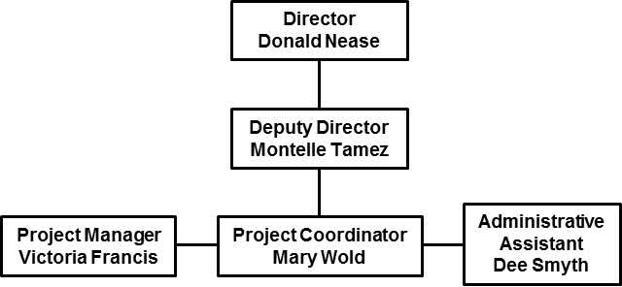

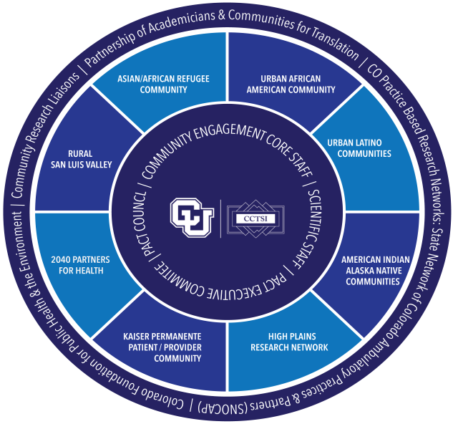The CCTSI has integrated community-based participatory research (CBPR) into programs that engage the wider community with research into the causes and remedies of health problems and disparities in underserved populations in Colorado and the nation. It has built on a rich history of practice-based and community-based research in the state, which now includes 18 established community-academic partnerships. These partner communities include rural and urban populations, American Indian and Alaska Native, Hispanic and African American groups, providing a unique opportunity for culturally proficient research emphasizing health disparities. The innovative Partnership of Academicians and Communities for Translation (PACT) brings academic/community partnerships into a sustainable and collaborative balanced (equal numbers of community members and academicians) governance group for bidirectional exchange, and fostering public trust in the research enterprise. PACT oversees a variety of activities, including 8 Community Research Liaisons, the Community Immersion Program, Bootcamp Translation program, CE Pilot Grants, community forums and other activities described more fully in the Community and Collaboration section of the grant application.

**Figure 2. CE&R PACT Council Partners and Structure**.

**Early Life Exposures Program (ELEP)**

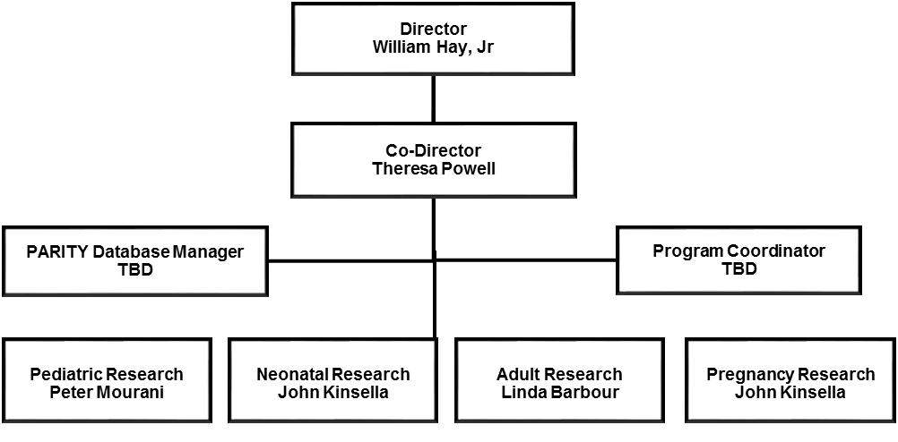The overall goal of ELEP is to support and promote clinical and translational research in children of all ages, pregnant women, and the mother-child dyad to improve child health and prevent diseases, thus preempting adverse outcomes that increase disease burden and the cost of health care over the life span. ELEP provides specific support for multidisciplinary, integrated, translational research focused on health problems that begin early in life and during childhood. The research initiative in ELEP addresses the life trajectory of the mother and child, initiating new collaborations among basic, clinical, and translational scientists in multiple disciplines and for providing a streamlined infrastructure for longitudinal studies to accommodate lifespan research.

ELEP promotes research of the highest scientific and ethical quality in special populations by supporting investigator knowledge and training in the special regulatory protections in place for these populations, pre-reviewing protocols for scientific merit and insuring that adequate participant protections are specified, and providing information and resources for families considering study participation. ELEP investigators frequently use the Perinatal CTRC and CHCO CTRC facilities and resources in their research studies.

The ELEP Perinatal Research Facilitation Committee is a group of experienced perinatal investigators, research nurses, and coordinators who assist investigators working with pregnant women, preterm infants, and newborns. This committee assesses the feasibility of each protocol, identifies potential overlap with existing studies and, if so, facilitates sample sharing, fosters collaboration between investigators working in similar areas, and assures that investigators are aware of existing data and biobank resources that could aid their research. This committee is vital to promote collaboration, insure maximal utilization of rare and/or small samples (eg. from premature infants), and prevent competitive recruitment of vulnerable populations.

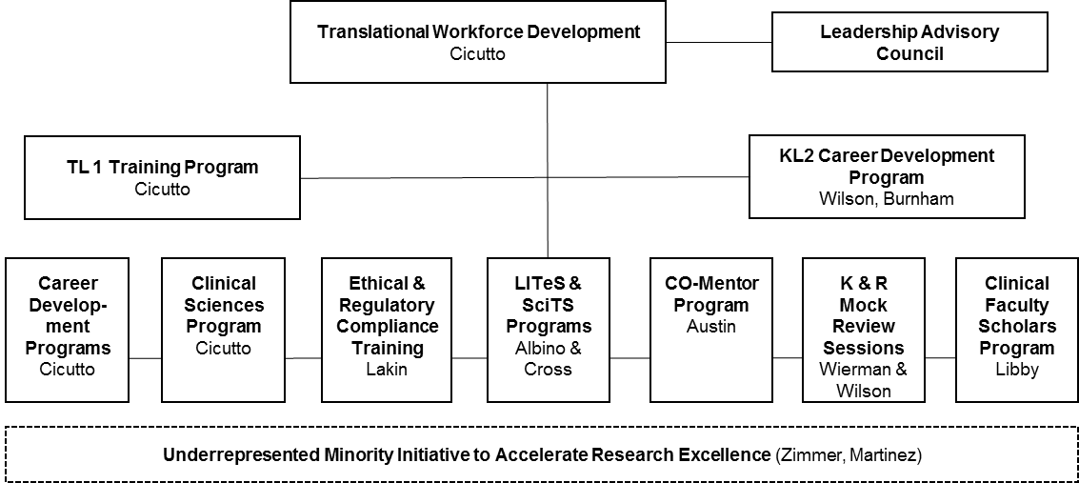**Translational Workforce Development (TWD) Program**

The TWD program provides clinical-translational scientists and trainees with knowledge, training, and career skills. TWD offerings span critical periods, from the beginning of research training at the pre-doctoral level through senior faculty. The aim of the TWD is to create a robust local workforce and a national leadership pool for clinical-translational research who are interdisciplinary, innovative, and highly motivated and successful. TWD leverages and integrates educational programs at CU-D and its partners, to provide skills training in strategic areas. Programs are intended to promote innovation and team collaboration, leading to research with broad implications for public health. A cadre of faculty, educators, and administrative staff are dedicated to providing programs of the highest quality. The TWD provides a broad menu of training and career development opportunities.

**Programs**

* TL1 Training program. This program provides integration between current training in molecular, cellular, and/or behavioral science, and whole body physiology and disease processes with clinical experience. Candidates are actively co-mentored by faculty with basic science and clinical research experience. This program currently has enrolled 8 PhD students each year but will be expanded and enhanced under the new award and will enroll up to 15 pre- and post-doctoral trainees per year with an emphasis on underrepresented minorities, and now to include students from Colorado State University.
* KL2 Mentored Career Development (Research Scholar) program. This program provides up to 3 years of funding for clinical translational research, education and mentored career development to train awardees in the optimal conduct of translational research with the ultimate goal of obtaining individual peer reviewed grant funding. This program supports 5 junior faculty at any one time.
* Clinical Sciences Graduate Program (CLSC). One of the first Clinical Sciences Graduate Programs in the country, this program awards MSCS and PhD degrees in 3 distinct specialty tracks: Clinical Investigation, Health Services Research, and Health Information Technology. This program enrolls 110-115 students at any given time and aims to train nationally competitive clinician/clinical translational scientists by providing a formal and structured educational and mentoring program. Graduates are trained to conduct rigorous and relevant patient-based research within stringent ethical and regulatory guidelines, and translate the evidence for community application. In addition, more than 200 other non-degree students attend CSLC classes each year.
* Clinical Faculty Scholars Program for developing junior faculty research independence. This program enrolls 4-5 learners per year and aims to help emerging investigators obtain a career development award (K08, K23 or foundation equivalent), or a first independent, extramural project award (R21, R01 or equivalent) through guided project development, educational seminars, grant writing classes, and mentorship. Each Faculty Scholar develops an individual career development plan and receives regular individual mentorship from four experienced senior researchers. This program acts as a pipelineof promising individuals into the KL2 program.
* Leadership in Team Science (LITeS) program is a yearlong program for mid-level and senior faculty to enhance leadership skills, foster team science by creating a network of colleagues who serve as resources for one another, expand opportunities for cross-disciplinary collaboration, and ensure that clinical and translational scientists have the skills for effective team leadership.  To date, LITeS has trained over 200 participants including deans, associate deans, department chairs, vice-chairs, and section heads, as well as senior leadership from hospitals, major research centers, and training programs. This program competitively enrolls 20-30 participants per year to work on solutions to high-level issues chosen by UCD leadership.
* Mock study section and grant review programs. These programs utilize mock study section pre-review of grants prior to formal submission. Participants of this program receive insight into the grant review process and help to improve the science and format of their applications thereby increasing their chances for success.
* Colorado Mentoring Training (CO-Mentor) training is a six day program which utilizes evidence-based strategies to teach mentor/mentee pairs the skills they need to get the most out of their mentoring relationships and develop the mentoring potential of their mentees.
* Clinical Research Education Program: Curriculum to improve regulatory knowledge and compliance and GCP and RCR application. Provides required regulatory courses (GCP,RCR, human subject protection including informed consent) for all people involved in CTR Variety of training forums: seminars, courses, individual consults, online modules. Over 700 attendees annually*.*

**Innovation Ecosystem (PIVOT)**

**Innovation Corps (I-Corps™)** uses proven customer-discovery methodologies for startups. It was developed for academic researchers by serial entrepreneurs working with the National Science Foundation. I-Corps@CCTSI is a team-based short course designed for faculty, staff and students. The program guides teams through the early stages of customer discovery where they can test the business model hypotheses for their technology or idea to accelerate the translation of innovations from the lab to clinical practice. I-Corps@CCTSI leverages and partners with other entities which promote innovation such as the UCD Technology Transfer Office and the Children’s Hospital Colorado Center for Innovation. These partnerships facilitate collaboration, access to a large knowledge base and investor pool, access to proof-of-concept funds, and interdisciplinary expertise.

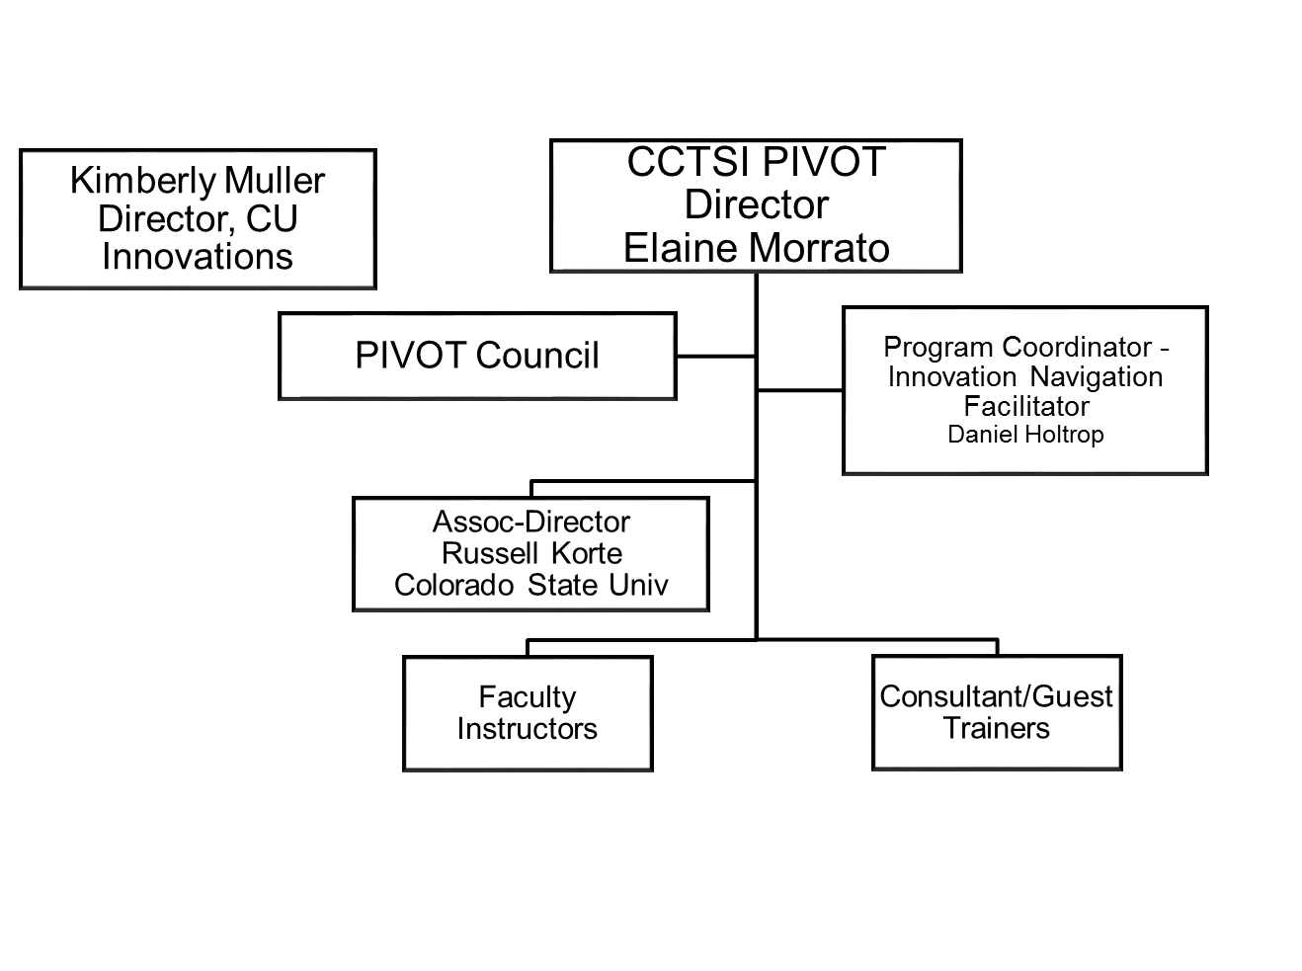

**Regulatory Knowledge and Support Core (RKS)**

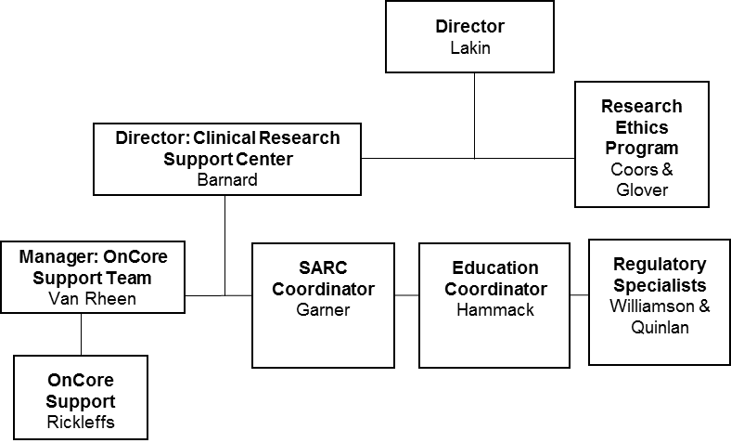

**RKS** helps CCTSI members navigate through regulatory requirements and provides training and consultation in the responsible conduct of research. The RKS and CRAO share 5,000 sq ft of office, conference room, and collaboration space on the ground floor of Building 500 at the Anschutz Medical Campus. This consists of 3 conference rooms, 27 cubicles, 4 offices, a storage room, a communal lunchroom, and collaborative spaces including open, communal printer/ copier and seating areas. This “google-style” space houses RKS staff as well as staff from UCD contracting, CCTSI Scientific and review Committee (SARC) and research education, the Trial Innovation network (TIN), CU Innovations, OnCore team members, and UCH billing. This novel arrangement, housing parties within a functional cross-institutional team space rather than in space assigned by each staff member’s employer spread over campus, facilitates collaboration and direct access to the knowledge and expertise necessary to assimilate information quickly, brainstorm and resolve problems in real time, and provide solutions, workflows, and training opportunities that are consistent across AMC. In addition, RKS space is the same building as many entities essential for the safe and efficient conduct of translational research such as COMIRB, other regulatory office, and the Dean’s Office, which provides further team building and collaboration opportunities.

***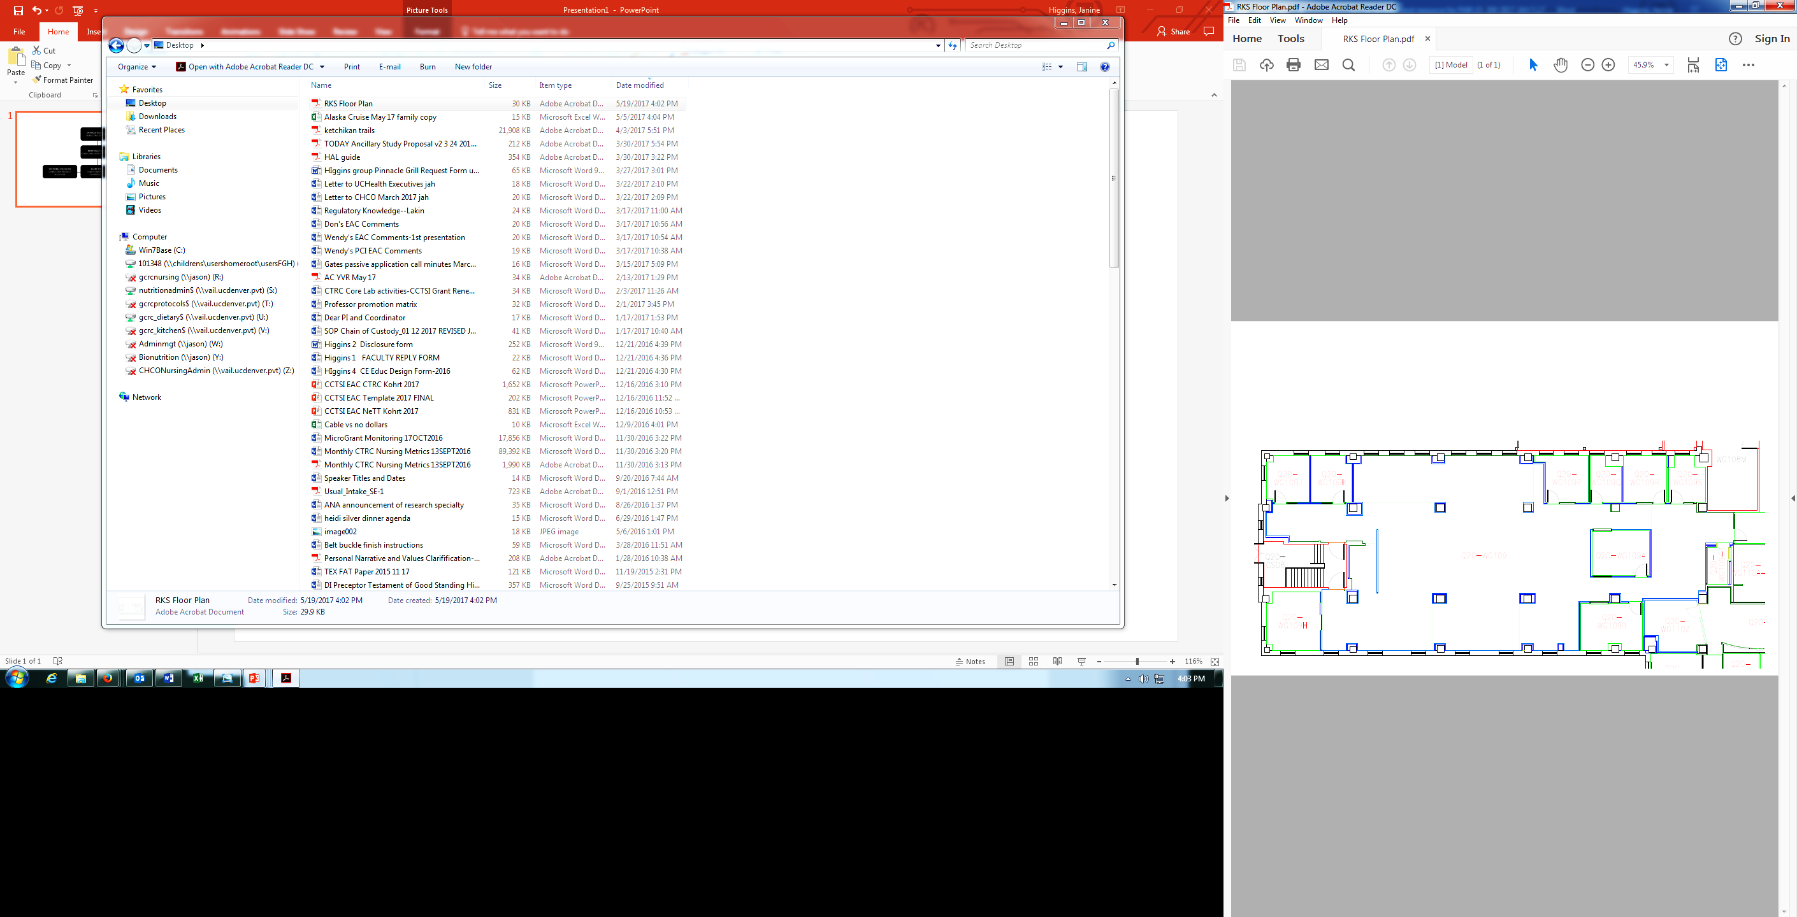*Figure 3. RKS space with dedicated areas for interaction and collaboration.**

**Network Capacity : the Trial Innovation Network (TIN) Hub Liaison Team**

The Trial Innovation Network (TIN) Hub Liaison Team encourages, supports, and promotes multi-center investigations, and provides an environment where NIH-supported clinical trials are conducted efficiently, compliantly, and with the highest quality. The team consists of the Hub PI, Director, Medical Directors for both adult and pediatric studies, a project manager, central IRB liaison, contracting liaison, recruitment facilitator, research navigator and an honest broker for recruitment. The TIN team will build on the strong clinical research

structure currently in place to support clinical trials within the CCTSI and expand the opportunity to both 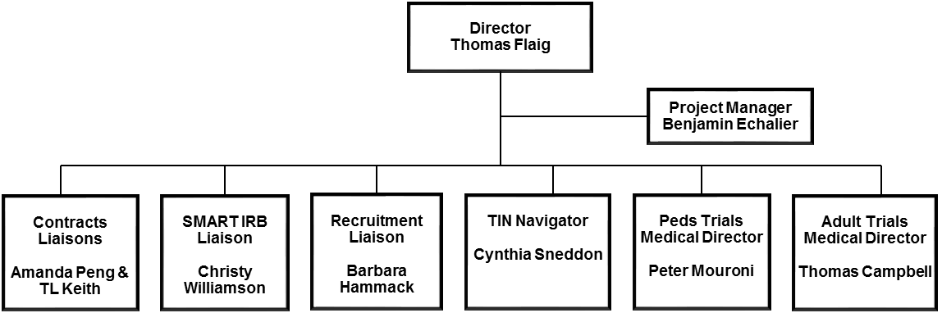propose multi-center trials via the TIN and recruit patients locally for TIN-sponsored trials. The TIN team has members that are imbedded in the same space as the Regulatory Knowledge and Support Core and the CCTSI office space, to facilitate collaboration, leverage existing expertise, and contribute to the overall goal of streamlining the startup and coordination of multi-site clinical trials.

The local TIN Liaison Team will include:

* Director – Thomas Flaig, MD

Dr. Flaig, Professor of Medicine, is the Chief Clinical Research Officer for UCHealth and the Associate Dean for Clinical Research at the University of Colorado. Dr. Flaig is a Medical Oncologist with extensive experience in conducting clinical trials in the area of Genitourinary Cancers. He has been the local PI on more than 25 clinical trials, and also as the national PI on NCI/National Clinical Trial Network trials. He previously served in the University of Colorado NCI Comprehensive Cancer Center as the Cancer Clinical Trials Office Medical Director and subsequently as the Associate Director of Clinical Research. *He will be responsible for overall operations of the TIN, participation in conference calls and meetings, and communications with TICs and RICs and NCATS.*

* Medical Director (Adult health) – Thomas Campbell, MD

Dr. Campbell, Professor of Medicine, Division of Infectious Diseases, also has served as Medical Director of the UCH CTRC since 2008. His research focus is the use of antiretroviral agents to treat and prevent HIV infection and AIDS-related complications. He is Site Leader for the UCH Clinical Research Site in the NIAID AIDS Clinical Trials Group (ACTG) and a member of the ACTG Executive Committee. He led the design, implementation, and dissemination of 3 NIH-funded international clinical trials from 2002-2016. He has served as the local PI for 52 ACTG and HIV Vaccine Trials Network clinical trials and 33 pharmaceutical industry clinical trials. Dr. Campbell served as a liaison for the establishment of new ACTG clinical trials sites in Zimbabwe and South Africa from 2003-2008. *He will be responsible for operations and implementation of adult clinical trials of the TIN.*

* Medical Director (Child health) – Peter Mourani, MD

Dr. Mourani, Associate Professor of Pediatrics, is the Medical Director for the Children’s Clinical Research Organization​ (CCRO) and works with investigators to optimize clinical research operations at CHCO in this capacity. He is also Director of Clinical Research in the Section of Pediatric Critical Care Medicine at CU SOM and Children’s Hospital Colorado. Dr. Mourani’s NIH-funded research focuses on the mechanisms of bronchopulmonary dysplasia and pulmonary hypertension in children. *He will be responsible for operations and implementation of child health clinical trials of the TIN.*

* TIN Project Manager – Benjamin Echalier, MS, MBA, CCRP

Mr. Echalier is the manager of the CCTSI Research Coordinator team at CU-AMC and has worked to support regulatory submissions, data entry and other general coordination for clinical trials in multiple specialties. He has over 5 years of experience managing clinical research teams for both CROs and in the academic research environment. He was most recently a senior project manager for a large CRO responsible for oversight of clinical trials for a variety of sponsors. *He will be responsible for project management and implementation of TIN protocols at our site.*

* Central IRB Liaison - Christy Williamson, CCRP

Ms. Williamson is the Senior Facilitation Manager with the Clinical Research Support Center at UC Denver and has a strong background in clinical research and regulatory and IRB coordination. She has been an Education Consultant in the same group and has extensive experience working with multiple IRBs, including with the central IRB mechanism, throughout her career. *Her responsibilities will be to ensure timely and compliant IRB reliance agreements, facilitate use of central IRBs, and streamline local IRB processes for TIN studies.*

* Contracting Liaison - Amanda J. Peng, MS

Ms. Peng has a Master’s Degree in Health Science and Technology from the Massachusetts Institute of Technology and currently serves as the Senior Clinical Trial Contracts Manager at CU-D. She has worked as a clinical research associate in the UCSF Department of Orthopedics, was a Trainer and Team manager for the Clinical Trial division budget team at Stanford University, and is currently a Senior Clinical Research Contracts Manager at CU-Denver. She has a strong background in budgets, contracts, team management, process improvement, change management, institutional training, and identification of complex issues with attention on solution focused communication and problem solving. *Her responsibilities will be to facilitate timely and complete execution of contracts related to TIN studies.*

* Recruitment Facilitator - Barbara N. Hammack, Ph.D.

Dr. Hammack has been the Research Subject Advocate (RSA) for the CCTSI since 2008. She has taught regulatory science and research ethics and is the director for an investigator focused clinical trials course. She has close connections and has organized multiple recruitment resources at UC Denver and nationally that put her in a strong position to facilitate recruitment at our site. *Her responsibilities will be to develop, implement and facilitate research participant recruitment and retention strategies in coordination with the RICs*.

* Research Navigator - Cynthia Sneddon MPH, CCRC

Ms. Sneddon is a facilitator in the Clinical Research Support Center at UC Denver and provides one-on-one guidance to PIs and study teams with regards to regulatory areas, IRB submissions and other issues that need attention. She has an extensive clinical research background, with experience as a research coordinator, regulatory coordinator and IRB coordinator at UC Denver. *Her responsibilities will be to assist investigators and their teams in accessing and coordinating the various resources of the TIN, RICs, TICs and CCTSI in order to either submit a TIN request or be a local site PI for a TIN study..*

* Honest Broker for recruitment – TBA

The Honest Broker will be a new position to facilitate the identification of subjects for clinical trials by working closely with the Health Data Compass team (our research data warehouse which includes patient data from UCHealth, CHCO and CU Medicine. This Honest Broker will work closely with investigators to identify and contact potential participants with whom the investigators do not have a treatment relationship.

* Clinical site operations coordinator
  + CHCO - Jeannine Duffield, BA, Director of Research Administration and Operations, CHCO Research Institute
  + UCHealth – Laurie Blumberg-Romero, MA, CRA, Director of Research Administration for UCHealth

**Translational Informatics**

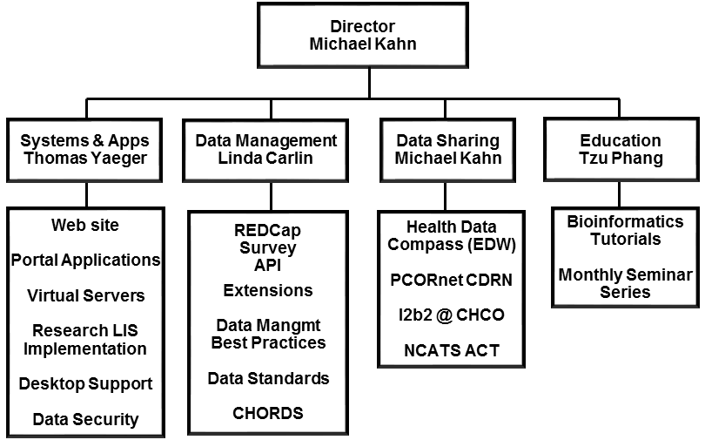The Translational Informatics function of the CCTSI develops research informatics tools and provides training and support for research informatics needs. The Data Management team has implemented and oversees REDCap, a web-based, HIPAA-compliant study data management solution that is straightforward and robust and being adopted widely by members of the national CTSA consortium. Through SeDLAC (Secondary Database Library and Analysis Center), CCTSI members have access to large national population-based datasets from NCVS and AHRQ. The System Services team maintains approximately 20 servers running several applications, at the department and enterprise level, for data management needs across the CCTSI. In addition, System Services manages backups, security, networking, access controls, desktop support for the CCTSI administration core and CTRCs, and CCTSI website development.

**CCTSI website**

The CCTSI website (<http://cctsi.ucdenver.edu>) acts as the portal of entry for faculty, trainees, research associates, other university personnel, the public and the private sector to gain access to services and resources, applications, RFAs, training opportunities, success stories, and announcements about our programs. The website receives over 4,200 visits per month accessing over 14,000 page views. CCTSI membership is required to utilize services and training programs, with membership exceeding 4,350 as of May, 2017. Membership is available to faculty, trainees, research associates, community members and the private and public sectors and is obtained through an online registration form. COLORADO Profiles, a web-based searchable faculty biomedical research database for the entire University of Colorado system (<http://profiles.ucdenver.edu>) managed by the Informatics Core of the CCTSI, receives over 10,000 visits per month for over 40,000 page views.

**Health Data Compass**

Health Data Compass (Compass) is a multi-institutional data warehouse funded by the University of Colorado Health System, Children’s Hospital Colorado, CU Medicine (formerly UPI), and the University of Colorado School of Medicine. Unlike existing data resources in these institutions, Compass is specifically designed to support data discovery and data sciences methodologies that integrate, harmonize, and link large-scale biological, clinical, administrative, regional, state and national data sets, such as environmental exposures and CDC national data sets (Figure 1). Compass currently contains inpatient and outpatient data including patient, encounter, diagnosis, procedures, medications and laboratory results (see <http://healthdatacompass.org> 🡪 Available Data). New initiatives include text extraction from structured reports and natural language processing (NLP) techniques for concept extraction from unstructured data. Using both traditional relational database technologies and novel cloud-based non-relational database architectures, Compass is specifically focused on developing efficient data acquisition, processing and linkage methods to create unique data sets organized for data analytics and visualizations. For example, we have developed new record linkage methods that have superior performance over existing methods when linkage variables are missing or corrupted115. Many of the core large-scale skills and technologies used in the development of national data sharing networks previously described are being reused and expanded by Compass. By design, Compass has been architected to accept data from disparate data sources and has established a processing pipeline to incorporate these new data sources into the Compass warehouse. We will leverage this mature set of processes to incorporate data from the highly dispersed and heterogeneous data sources across the RMPMI cohort.



**Figure 4: Data sources, integration and sharing capabilities of Health Data Compass.**

Patient data is integrated into the Compass enterprise data warehouse through processes developed by specialized engineers to extract data from various source systems, transform that data into a common schema, and load the data into the data warehouse.  The source data systems include clinical operational systems like EHRs, research databases, biorepositories, and processed *omics data (VCF files).  The integration of these disparate data is linked to create a longitudinal patient record.  Relevant clinical and *omics data is then extracted into data marts that allow for easy queries to be made for the relevant research projects.  The Compass enterprise data warehouse utilizes a variety of technologies to link phenotypic and molecular data, allowing end-users to execute queries that combine clinical and *omics attributes.

Compass is housed on the Anschutz Medical Campus of the University of Colorado Denver in Aurora, Colorado.  The Compass office provides 1800 sq. ft. of private office and conference room space for personnel. The Compass data warehouse consists of a variety of on-premises and cloud-based computing resources that will be allocated in support of this project depending on the specific technical demands of the project and the participating clinical sites. These resources include a 24-core Oracle Exadata database server with 512GB RAM and over 70TB storage; a stack of 12-core, 256GB Sun servers for middleware and web applications. Compass resources are hosted within the University of Colorado’s Office of Information Technology data center, a 2000 sq. ft. secure environment constructed specifically to support mission critical servers and equipment. Physical access to this server is badge-controlled and tightly defined to a list of critical personnel (2-3 people) to ensure tight security.  PHI data stored on this server is not accessible to any end-user until it has been fully integrated from the source systems, transformed into the proper data model, and then subsetted into data marts which are then made available to for end-users to query.  The Compass informatics environment is hosted and operates as a HIPAA-compliant solution for storing and accessing sensitive PHI data.  In addition, Health Data Compass has legal and regulatory agreements in place with Google for use of their massively scalable Google Cloud Platform, including next-generation data integration and analysis platforms like Google BigQuery and Google Genomics.

**AMC Computational Resources**

***Anschutz High Performance Computing Exchange (AHPCE)***

The Translational Informatics and Computational Resource (TICR) is an integral component of the Colorado Center for Personalized Medicine (CCPM).  This in-house, comprehensive, stand-alone biocomputing unit supports a multidisciplinary, robust computing resource to foster omics-based research using high-dimensionality data (*e.g*., genomics, transcriptomics, microbiomics, proteomics, metabolomics) and development and implementation of computational methods and tools for sequence analysis and systems biology approaches.

***Computer Cluster***

The Translational Informatics and Computational Resource (TICR) computer cluster is designed with a minimum of 768 cores (Xeon E5-2680 v3 at 2.5Ghz), 4TB of RAM and 3.7 PB of useable storage. This cluster includes all necessary HPC components, including but not limited to a scheduler (SLURM), manager nodes, master nodes, login nodes, compute nodes, storage and cluster management software. The storage array is designed to provide a minimum of 3.7 PB of useable data storage for both home directories and scratch, using IBM General Parallel File System (GPFS). The processing network for the compute cluster consists of Infiniband switches, providing a low latency and high bandwidth interconnect for parallel computations and storage access. The compute cluster has redundant 10 gigabit Ethernet connectivity to OIT’s current network core and management switches, and can easily expand both in terms of network, compute and storage capacity based on need.

***Application Cluster***

The HPC environment also includes an application cluster, which consists of six physical servers running VMware vSphere virtualization, plus a dedicated fibre channel SAN. The application cluster is designed for redundancy and high availability. Each server has a minimum of 36 Xeon v3 cores at 2.3Ghz and 256GB of RAM. The fiber channel SAN is dedicated to the application cluster and includes 30TB of solid state disk. This array is able to be easily expanded to support future storage growth. The application cluster has redundant 10 gigabit Ethernet connectivity to OIT’s current network core and management switches, and can be easily expanded in terms of computation resources and storage.

***High Memory Nodes***

The TICR compute cluster currently includes one additional high memory compute node with 36 Xeon v4 cores and 1.5 TB RAM, to support high memory workloads such as experimental sequence alignment techniques.

***Back-Up Solution***

A file-level end-to-end back-up solution will be implemented with initial back-up requirements of 500 TB of protected data, with a design optimized for long term retention.