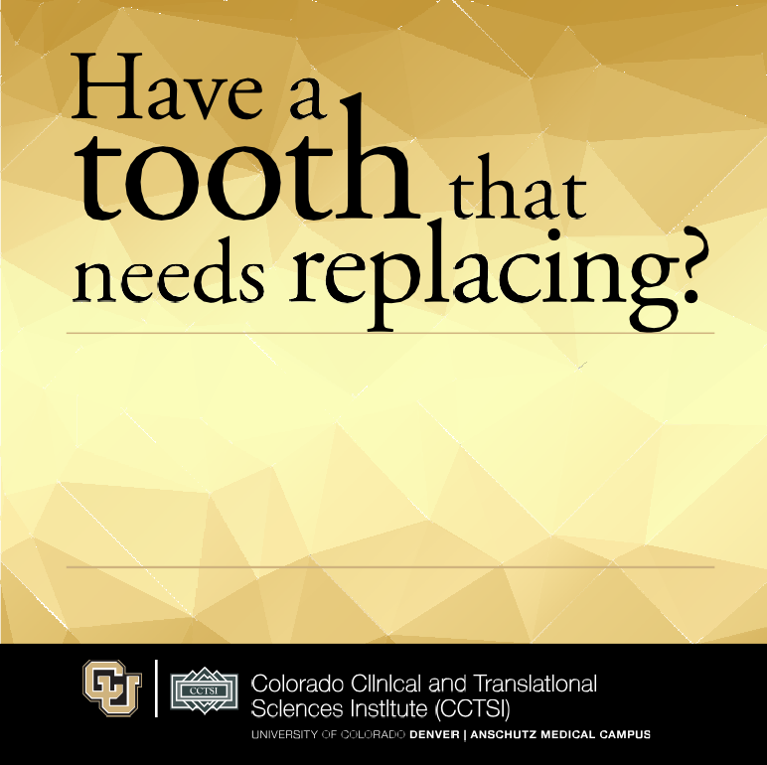
If you have a tooth that needs to be extracted and replaced with a dental implant, you may qualify for a tooth socket restoration research study. Researchers at the University of Colorado School of Dental Medicine are evaluating a socket-augmentation procedure that may improve the appearance and functioning of dental implants.

Qualified participants over age 18 will receive:
- A screening exam
- Study-related visits and monitoring by oral surgeons
- Compensation will be provided

If you or someone you know would like to learn more,

contact Wendy Meyer at (303) 724-XXXX

COMIRB#
Name, Principal Investigator

