Twilio Guide for Vanderbilt/Meharry End Users

  - Written by Laura McLeod/Vanderbilt University Medical Center

Acknowledgements
This guide is adapted from guides developed by REDCap Administrators Amanda Miller/University of Colorado Denver and Taryn Stoffs/University of Florida as well as input from REDCap administrators Andy Arenson/Indiana University, Chris Battiston/Women’s College Hospital, Erik Benton/OHSU, Leila Deering/Marshfield Clinic Research Institute, Ruthie Knowles/National Jewish Health, Eduardo Morales/Partners Healthcare, Maxx Somers/Cincinnati Children’s Hospital, Rob Taylor/Vanderbilt University Medical Center, and Shang Wei/UC Davis.

Table of Contents
Acknowledgements 1
How to navigate this User Guide 5
Finding the latest version of this Twilio User Guide 5
Corrections/suggestions for this Twilio User Guide 5
What is Twilio? 6
Compatibility with REDCap features 6
Delivery methods via Twilio 7
How to set up Twilio 8
Important information about uninterrupted service 8
Requesting Twilio on a project 8
Configuring Twilio 9
Language/Gender for Voice calls 9
Modules in which Twilio will be enabled 10
Survey-specific settings 10
Default invitation preference 11
Using a multiple choice field to designate delivery preference 11
Designate a phone number 12
Append response instructions to questions 12
Overlapping SMS invitations 13
For One-way communication 14
For two-way communication 14
Project Design 14
If collecting survey responses via text/call 14
Analyze surveys for SMS & Voice Calls 14
Message delivery 15
Public Survey Link 15
To set a participant’s delivery preference manually 18
To set a participant’s delivery preference automatically 19
To change a participant’s delivery preference 20
Composing the survey invitation via Participant List 22
If the Invitation type is Use participant’s preference (default invitation type) or SMS invitation (contains phone number to call) or SMS invitation (reply via SMS to receive voice call) 23
If the invitation type is SMS invitation (contains survey link) or SMS invitation (take survey via SMS) 24
If the invitation type is Voice call (participant receives voice call) 24
Using a data entry form to build a participant list 24
Setting the delivery preference 25
Automated Survey Invitations 25
If the Invitation type is Use participant’s preference (default invitation type) or SMS invitation (contains phone number to call) or SMS invitation (reply via SMS to receive voice call) 25
Stop Logic in Automated Invitations 26
Datediff/today calculations in Automated Invitations 27
Alerts & Notifications 27
Setting up your project to use Twilio in Alerts & Notifications 28
To create an Alert that uses Twilio 28
Stop Logic in Alerts 29
Checking the Notification Log for past and future alerts 30
Datediff/Today calculations in Alerts 30
Message design and content tips 31
Line breaks 31
Character limits 31
Message content limitations 32
Carrier Filtering 32
Project Management tips 32
Change in participant phone number 32
If using the Participant List… 32
If using a phone-validated number field… 32
Longitudinal Projects 32
Overlapping messages 34
Troubleshooting errors 34
Incoming messages from participants 35
Best practices/Tips 35
Testing 35
Twilio Registry 36
Fully complete any survey invitations that you send to your own cell phone 36
Ask your participants to add the Twilio number to their phone’s address book 36
Reasoning 37
Advising your participant that charges may apply 37
Asking participants to confirm that they agree to be contacted by text or phone 37
Carrier Filtering 37
Checking Survey Invitation Log/Notification Log 37
How Twilio and REDCap work together 38
SMS Regulatory Guidelines and best practices 38
Security 38
Authentication 39
Risk Assessment 39

How to navigate this User Guide
- You can use Ctrl+F to search for a keyword within this User Guide
- You can click on the Bookmark icon to find the section you would like to jump to:
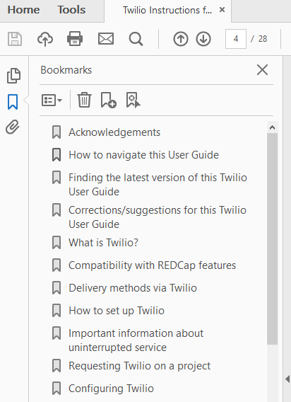

Finding the latest version of this Twilio User Guide
This User Guide may be updated from time-to-time. To make sure you are referencing the most recent version, please visit the Vanderbilt Meharry resource page. You can get to that website by clicking the hyperlink above. You can also always find the link to it on the login screen or at the top of the Help & FAQ tab within REDCap.

Corrections/suggestions for this Twilio User Guide
If you have corrections/suggestions for this Twilio user guide, please email them to redcap@vumc.org.

What is Twilio?
- A third party program (www.twilio.com) whose service can be enabled on a REDCap project
- When a REDCap project has Twilio enabled on it, a user on the project can send information and/or survey invitations to participants as a text message or as a voice call
- Twilio is secure to use, but be sensitive about PHI and sensitive information—think about who might have access to your participant’s phone

Compatibility with REDCap features
Most of REDCap's survey features still function much the same when taking a survey via SMS or as a voice call. This includes the enforcement of required fields, field validation, branching logic, using the Survey Queue for multiple surveys (only works with Auto-Start enabled), survey email notifications and confirmations, the Participant List, Automated Survey Invitations, survey Stop Actions, and computer adaptive tests (CATs) downloaded from the REDCap Shared Library. One of the few survey features that is not compatible is the Survey Login feature.

Additionally, if you are using an adaptive instrument from the REDCap shared library (like a PROMIS instrument), some of those instruments contain hidden fields. Hidden fields may cause the survey to stop for the participant (they won’t receive sequential questions via text). If that is the case, you will NOT want to have the participant complete the survey via text response, since adaptive instruments are not editable.

Delivery methods via Twilio
Voice Call options via Participant List
- Initiate survey as voice call | REDCap calls the respondent. They take the survey via phone, using the number pad for answers. Questions can only be in choice single answer format (yes/no, true/false, multiple choice radio button) or a number-validated text field.
- Invite via SMS to take as voice call (respondent calls REDCap) | REDCap texts the respondent a Twilio phone number, which is purchased in and affiliated with your Twilio account. The respondent calls that Twilio number when they are ready to take the survey. They take the survey via phone, using the number pad for answers. Questions can only be in multiple choice single answer format or a number-validated text field.
- Invite via SMS to take as voice call (REDCap calls respondent) | You provide your respondent with a Twilio phone number, which is purchased in and affiliated with your Twilio account. The respondent texts that number with a pre-defined message when they are ready to start the survey. REDCap then calls the respondent. They take the survey via phone, using the number pad for answers. Questions can only be in choice single answer format (yes/no, true/false, multiple choice radio button) or a number-validated text field. NOTE: this option is sometimes preferable to option 2 above because some phone carriers do NOT charge their customers for incoming calls.

SMS text options
Initiate survey as SMS conversation | REDCap texts the respondent the actual survey questions. The respondent uses the number pad and keyboard for their answers. Questions can only be in multiple choice single answer format or a number-validated text field. NOTE: THIS IS NOT HIPAA-COMPLIANT AND IS NOT RECOMMENDED FOR MOST PROJECTS
Send survey invitation via SMS | REDCap texts the respondent their survey link. The respondent clicks that link to open their survey in a browser. They take the survey as usual, just as if they had clicked the survey link in an email.
Send information via SMS | Using the alerts & Notifications application within your REDCap project, you can use Twilio to send information (not collect responses) to a participant. It is critical that you NOT send any PHI in a message.

Effectively, this leads to three new ways that a participant can take a survey:
- Mobile browser, via texted link, instead of emailed link
- Voice
- SMS/text (insecure)

How to set up Twilio
- Go to www.twilio.com and create an account
- Set up a payment method—you can use a credit card or PayPal
- Buy a phone number; numbers are $1/month
  - Please verify cost with Twilio – their rates may be subject to change
  - Each phone number is specific to a REDCap project – you need to buy a Twilio phone number for each REDCap project for which you want Twilio functionality
  - You can select specific capabilities for the phone number (text, multi-media messages)
  - You can select a local, national, toll free or mobile number
- Turn off the Request Inspector feature
  - This feature stores data on Twilio’s server and is not HIPAA-compliant, so it must be off to use Twilio with REDCap
  - Find it at this path (see image below):
    - Dashboard
    - Programmable voice
    - Settings
    - Request Inspector
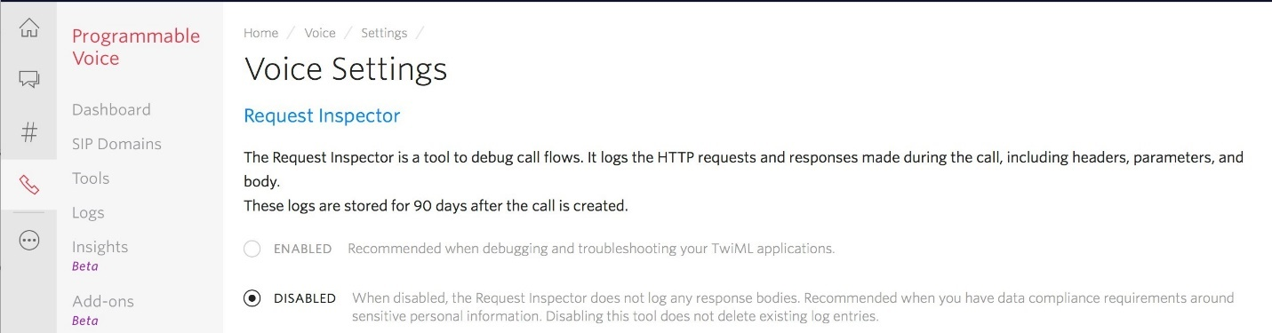

Disabling the request inspector disables the logging of phone and SMS Records in Twilio. This will allow REDCap to be the only place where records and logs are kept. REDCap will programmatically not allow set up unless this setting is disabled in your account. Disabling the request inspector (logging) is an important part of HIPAA Compliance. See the Security section of this document for more information.

Important information about uninterrupted service
There is a monthly fee that Twilio charges and additionally they charge a small fee for each message sent. You can view the rates for your Twilio account on their website. That is not something that REDCap has any purview over.

Keeping your Twilio account funded is important. If the account runs out of funds, the messages will not be sent. Funding a Twilio account happens outside of REDCap. So it is the user’s responsibility to make sure it is funded at all times.

Requesting Twilio on a project
At the Vanderbilt/Meharry REDCap installation, a REDCap administrator is responsible for enabling Twilio on a project. To request Twilio for your project, please fill out this survey. It will likely take a few business days between your request is submitted and when Twilio is available on your project. That is because there are several verifications steps the REDCap admin team needs to take in enabling Twilio on your project.

Configuring Twilio
After Twilio is enabled on your project, a new box will appear on the Project Setup page allowing you to configure Twilio:
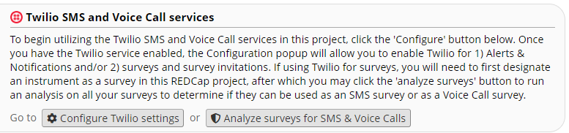

When you click on the Configure Twilio settings button you will see these sections:

Language/Gender for Voice calls
If you are using Twilio to contact participants via voice call, you can indicate the language/gender for the voice calls. This is a partial list of your choices:

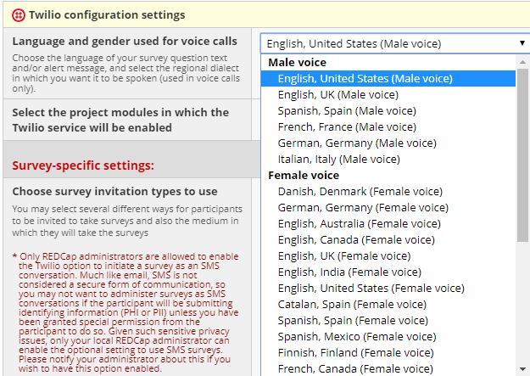

Modules in which Twilio will be enabled
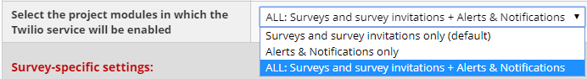

If you are using Twilio to send survey invitations, you can select any of the options in that drop-down list. Please see the section For two-way communication for tips on project design if you are using Twilio for surveys.

If you are only using Twilio to send a message that does not involve a survey, you can select the “Alerts & Notifications only” option. Please see the section For One-way communication for tips on project design if you are only using Twilio to send messages.

You would also select the “Surveys and survey invitations only (default)” or the “ALL” option if you are using an Automated Invitation to send information only (e.g. not including the smart variable survey link).

Survey-specific settings
You can select different options in this section of Configure Twilio Settings if you are using Twilio for surveys. If you are only using Twilio to send one-way messages (and NOT using an Automated Invitation as a vehicle to send a one-way messge), you do not need to tick any of the boxes in this section.

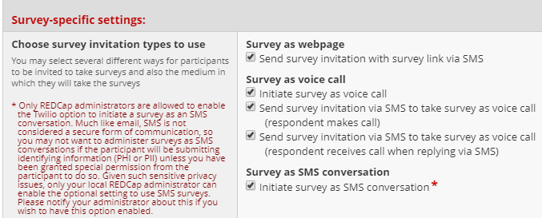

Default invitation preference
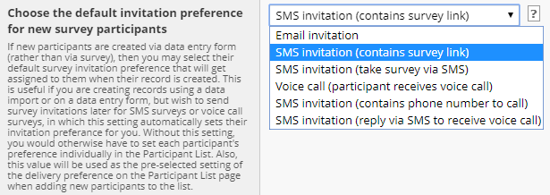

When adding participants to the participant list, you can choose the default invitation preference for how they will be sent their invitation. An individual's invitation preference can be changed at any time in the participant list. Then when you are ready to send your survey invitations to participants, you can choose the delivery method used for sending that batch of invitations. The preference does not have to be used when you are sending invitations, but it is provided as a convenience in case you have participants with several different invitation preferences.

Using a multiple choice field to designate delivery preference
You can create a multiple choice field in your REDCap project that can be used to automate the delivery preference of a participant. When creating the multiple choice field, you would need to use the following as the choice codes:

EMAIL, Email invitation
SMS_INVITE_WEB, SMS invitation (contains survey link)
SMS_INITIATE, SMS invitation (take survey via SMS)
VOICE_INITIATE, Voice call (participant receives voice call)
SMS_INVITE_MAKE_CALL, SMS invitation (contains phone number to call)
SMS_INVITE_RECEIVE_CALL, SMS invitation (reply via SMS to receive voice call)

So the codes (the string of text written prior to the comma (in all caps and with underscores) need to be written exactly as written above. You can modify the choice labels (the content that comes after the comma) any way you wish.

Once you have that multiple choice field in your project, you can go to Project Setup/Configure Twilio settings and in the Survey-specific Settings section, select your multiple choice field from the drop-down list that corresponds with the ‘Control each participant’s invitation preference using a multiple choice field section:

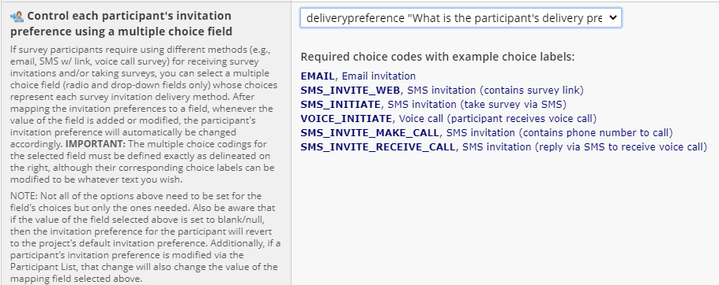

In the above example, the multiple choice field that was created was called ‘deliverypreference’. To see a demo of this feature, click here.

Designate a phone number
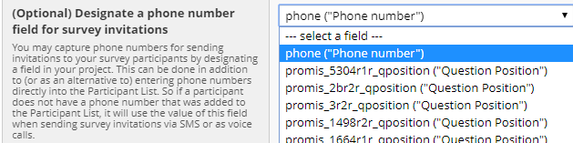

Similar to designating an email field for survey invitations, you can designate a phone number for survey invitations. Any text box field that has phone number validation will display in your drop-down list.

Append response instructions to questions
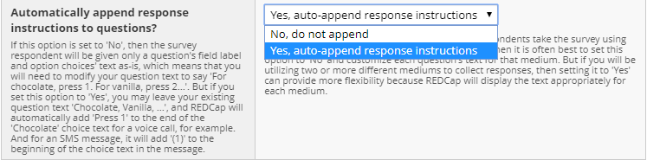

If you are planning to have all your respondent take the survey using only one medium (via webpage, SMS, or voice call), then it is often best to set this option to ‘no’ and customize each question’s text for that medium. But if you wil be utilizing two or more different mediums to collect responses, then setting it to ‘yes’ can provide more flexibility because REDCap will display the text appropriately for each medium.

Overlapping SMS invitations
You have some choices for overlapping messages if your project contains multiple surveys.

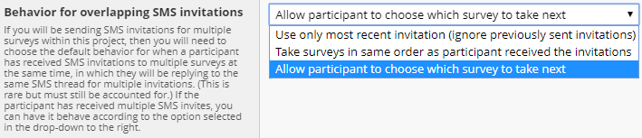

For One-way communication
If you wish to use the project to simply send information to participants you don’t need surveys enabled on the project. Instead, you can use the Alerts & Notifications application to create the messages that you want to send to the participants.

In Twilio configuration settings (found on the Project Setup page), select the options Alerts & Notifications only in the project modules section:
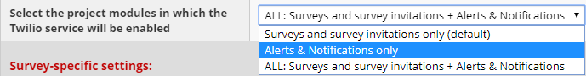

If you have your Twilio Configuration Settings set for Alerts & Notifications only, if a recipient replies to a Twilio text, they will receive this message: [Auto-Reply: This SMS phone number is not monitored]. That text is hard-coded so you do not need to do anything to set that up. You also are not able to customize that text.

See Message Delivery/Alerts & Notifications section of this User Guide for instructions on how to set up an alert to send your message.

If you are working with an older project and you have been using an Automated Invitation to send a one-way message, then you simply need to remember to remove the smart variable survey link that automatically gets added to the message section of the invitation. You will be prompted to add it in – you will need to keep dismissing the warning until it lets you save the message.

For two-way communication
If you wish to collect data from participants (either by sending them a survey link via text or by asking them to answer survey questions via text or phone call) there are some project design elements to keep in mind.

Project Design
- Surveys need to be enabled on the project
- Keep in mind that Action tags are not functional via Twilio
- For all voice and SMS text distribution options, we suggest keeping question language non-specific. Field labels should ideally not refer to specific sensitive or confidential data.

If collecting survey responses via text/call
The survey questions need to be designed using multiple choice field types and/or text boxes validated for number. No other field types are compatible with this module.

Analyze surveys for SMS & Voice Calls
As mentioned above, if you are collecting survey responses via voice call or text, the fields in your surveys can only be multiple choice or number-validated text box fields. To double-check that your questions are compatible with Twilio, you can click on the Analyze surveys for SMS & Voice Calls button on either the Designer page:
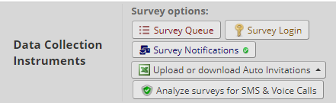

or the Project Setup page:

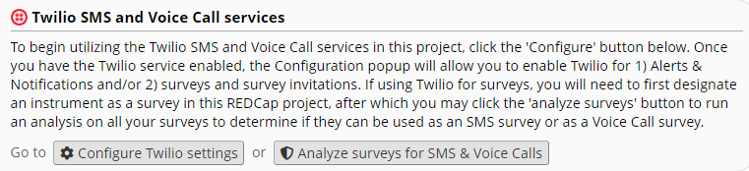

You will see a list of your instruments that have been enabled as surveys. If there are any compatibility issues, the cell in the Voice Call Survey Issues column will be red and will indicate the number of errors:

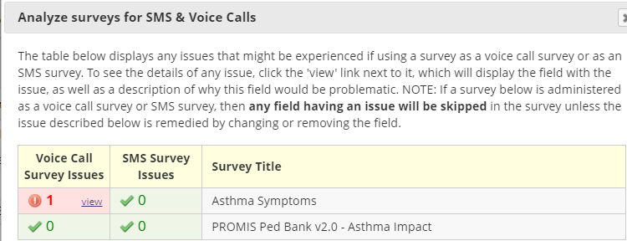

You can click on the ‘view’ link to see what the issue is. In this example, there is a question in the survey that is a text box field type but it does not have number validation on it:
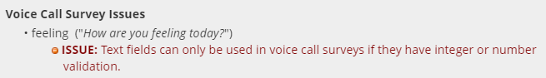
That is your cue to go into Designer for that survey and edit the field so that it complies with design requirements.

Message delivery

Public Survey Link
If the first instrument in your project is a survey, you have the option to invite participants to complete the public survey via voice call or SMS. To do this, click on Survey Distribution Tools on the left-hand navigation bar and you will see this in the bottom portion of your right-hand workspace:

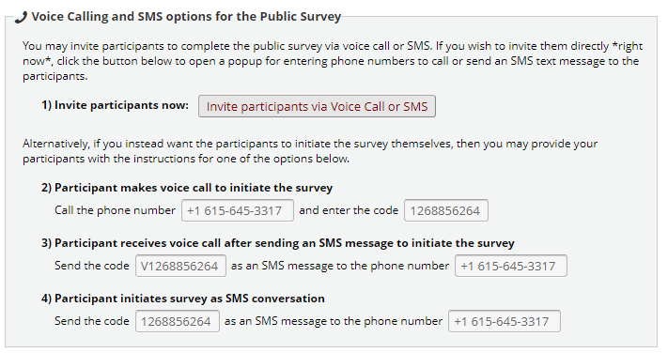

When you click on the ‘Invite participants via Voice Call or SMS button, you will see this:
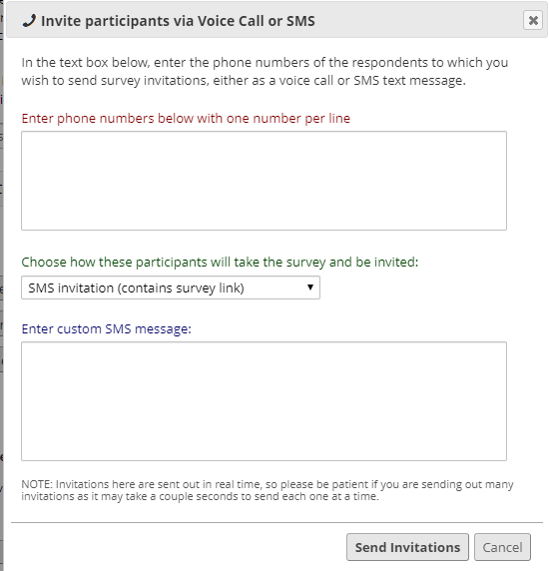

You enter the phone numbers one per line, just like you would enter email addresses one per line when using the Participant List to send survey invitations via email.

You can select the delivery method from the drop-down list:
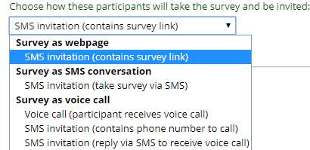

Note that there is a message box into which you can enter survey instructions. The participant will see those instructions in the text message they receive. This is separate from the Survey Instructions that the participant will see if a survey link is included and they click on that to take the survey.

It is best to keep your message very brief – the cell phone carrier may break up the message into separate texts if the message length is too long and it’s possible the texts may arrive out of order, like this:
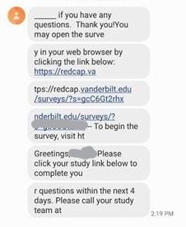
So consider only providing the survey link and a few words about it. Any further instructions can be included in the Survey Instructions which you set via Survey Settings.

To set a participant’s delivery preference manually
If you know the participant’s contact information ahead of time, you can add them to the Participant List and set their delivery preference. To do this, click on Survey Distribution Tools and then the Participant List tab. If you have several entries, consider sorting them by delivery preference so that you are bulk adding them according to their delivery preference.

For instance, if you have the following participants:

Name | Delivery preference | Email address | Phone number
Jena | Email | jena@test.com | 518-555-5555
Nicole | Text survey link | nicole@test.com | 518-555-6666
Barbara | Text survey link | barbara@test.com | 518-555-7777
Steve | Email | steve@test.com | 518-555-8888
Alecia | Voice call | alecia@test.com | 615-555-5555
Zinnia | Email | zinnia@test.com | 404-555-5555
Joe | Voice call | joe@test.com | 615-555-6666
Kristin | Text survey link | kristin@test.com | 206-555-5555

…you would want to sort them by delivery preference, so your list would look like this:

Name | Delivery preference | Email address | Phone number
Jena | Email | jena@test.com | 518-555-5555
Steve | Email | steve@test.com | 518-555-8888
Zinnia | Email | zinnia@test.com | 404-555-5555
Nicole | Text survey link | nicole@test.com | 518-555-6666
Barbara | Text survey link | barbara@test.com | 518-555-7777
Kristin | Text survey link | kristin@test.com | 206-555-5555
Alecia | Voice call | alecia@test.com | 615-555-5555
Joe | Voice call | joe@test.com | 615-555-6666

Next, you would take the first group (delivery preference = email) and add those to the participant list. You do that by clicking on the Add Participants button on the Participant List page and entering the email address and phone number for each person. Note that you put a comma between the email address and phone number:

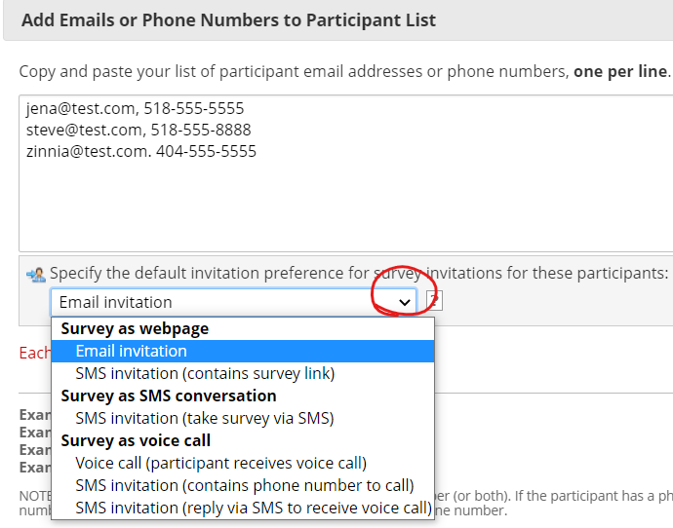

You then click on the drop-down arrow and select ‘email invitation’ as the default invitation preference.

Next, you can select the group of people whose delivery preference is text survey link and add them to the Participant List. You’ll select ‘Survey as a webpage – SMS invitation (contains survey link)”.

In essence, you’re bulk-adding participants, sorting by delivery preference.

To set a participant’s delivery preference automatically
You can select a multiple choice field (radio or drop-down fields only) whose choices represent each survey invitation delivery method. You will then map this field in your Twilio configuration settings.

For this to work, you will first create the multiple choice field, with the following choice codes:
EMAIL, Email invitation
SMS_INVITE_WEB, SMS invitation (contains survey link)
SMS_INITIATE, SMS invitation (take survey via SMS)
VOICE_INITIATE, Voice call (participant receives voice call)
SMS_INVITE_MAKE_CALL, SMS invitation (contains phone number to call)
SMS_INVITE_RECEIVE_CALL, SMS invitation (reply via SMS to receive voice call)

You can change the wording of the choice labels (the part that comes after the comma), but the choice codes (highlighted in yellow above), must be written exactly as depicted above.

That field can be anywhere in your project, including on a public survey link. In this example, let’s say we named the field ‘deliverypreference’.

Next, go to the Project Setup page (via the Project Home and Design section on the left-hand navigation bar) and click on ‘Configure Twilio settings’ in the Twilio SMS and Voice Call services section. In the Survey-specific settings scroll down to the “Control each participant’s invitation preference…” section and click on the drop-down arrow for ‘map the invitation preference to a field’:

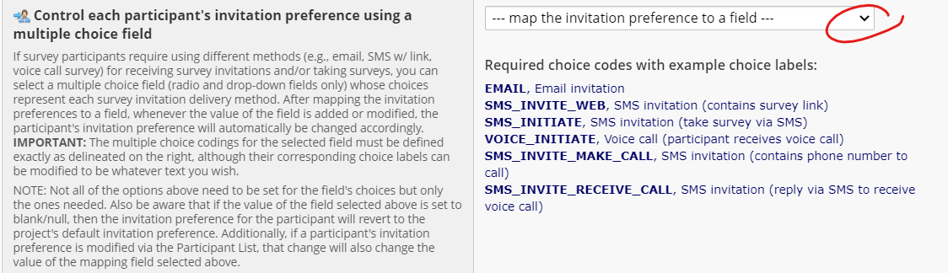

From that list, select the field you created (‘deliverypreference’) and click the save button.

Now, when a record is added and the delivery preference is set via that field, you will see the delivery preference mirrored on the Participant List page.

To change a participant’s delivery preference
To change how a participant receives the invitation, go to Survey Distribution Tools and click on the Participant List tab. Look in the Invitation preference column for the participant and click on the icon:
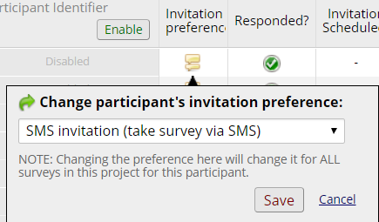

Clicking on the drop-down list will reveal these choices:
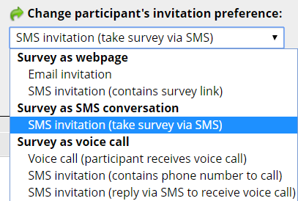

Please note: if an Automated Survey Invitation (ASI) or Alert is used to schedule an invitation, the delivery preference set at the time the ASI or alert was scheduled will remain in force, even if the user manually changes the preference after the fact. That is because REDCap does not know to check the preference again, after the invitation has been scheduled.

If you used the automated delivery preference setting with a multiple choice field, you can also go to that multiple choice field and change the preference by changing the answer to the question.

Composing the survey invitation via Participant List
When adding participants to the participant list, you can choose the default invitation preference for how they will be sent their invitation. An individual's invitation preference can be changed at any time in the participant list. Then when you are ready to send your survey invitations to participants, you can choose the delivery method used for sending that batch of invitations. The preference does not have to be used when you are sending invitations, but it is provided as a convenience in case you have participants with several different invitation preferences. Listed below are all the invitation types that are available in a Twilio-enabled project:
- Email invitation
- SMS invitation (contains survey link)
- SMS invitation (take survey via SMS)
- Voice call (participant receives voice call)
- SMS invitation (contains phone number to call)
- SMS invitation (reply via SMS to receive voice call)
- Use participants preference

These are the elements of composing the survey invitation:
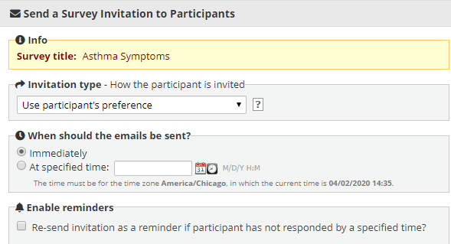

If the Invitation type is Use participant’s preference (default invitation type) or SMS invitation (contains phone number to call) or SMS invitation (reply via SMS to receive voice call)
You will see a Compose Message box with some text in red – please read that text! (see image below)
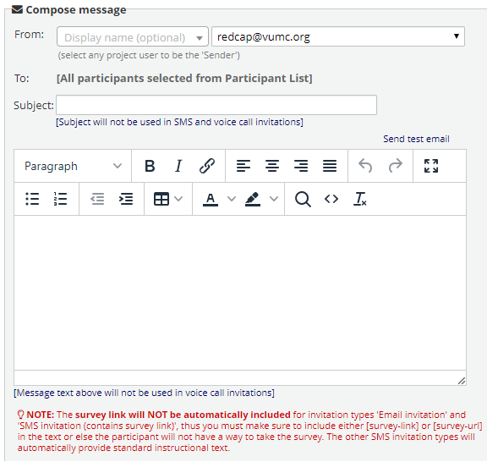

It is best to keep your message very brief – the cell phone carrier may break up the message into separate texts if the message length is too long and it’s possible the texts may arrive out of order, like this:
So consider only providing the survey link and a few words about it. Any further instructions can be included in the Survey Instructions which you set via Survey Settings.

If the invitation type is SMS invitation (contains survey link) or SMS invitation (take survey via SMS)
REDCap will pre-populate your message box with the smart variable for the survey link. You must leave that smart variable ([survey-link]) in the message. You are welcome to edit any of the other text.

If the invitation type is Voice call (participant receives voice call)
There is not a subject line or message box for you to complete. Instead, the information that the computer speaks to the participant is taken from Survey Instructions and the field labels for each question.
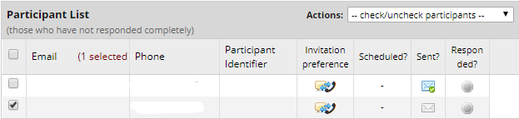

Using a data entry form to build a participant list
You can create a data entry form that has a phone-validated text box field in it. With this setup, you would enter the participant’s phone number into a record. That information essentially builds your participant list for you.

This is the field that you would designate in the Twilio Configuration settings (via the project setup page):
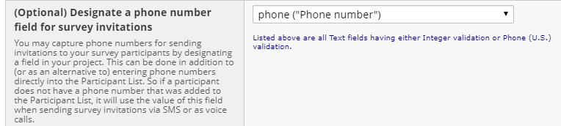

Setting the delivery preference
To set how a participant receives the survey invitation, go to Configure Twilio Settings on the Project Setup page: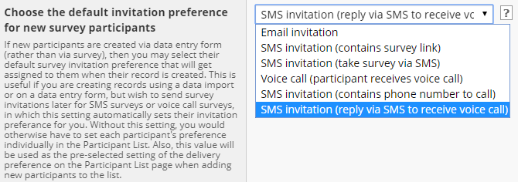
Alternatively, you can use a multiple choice field to automate the delivery preference of a participant. You can find instructions about how to do that by going to Configure Twilio Settings (via the Project Setup page) and in the Survey-specific settings section, look for this:

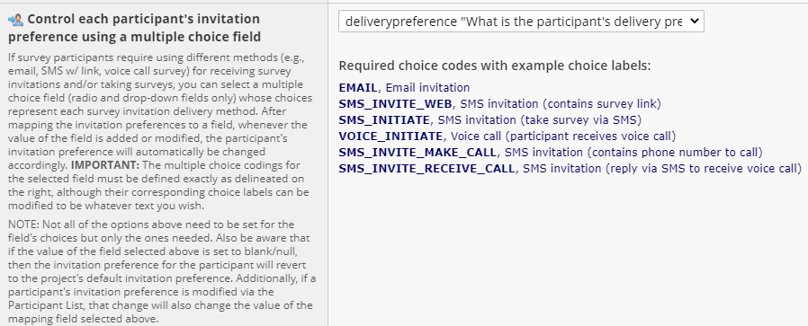

To see a demo of this feature, click here.

Automated Survey Invitations
If you wish to use Automated Invitations, you will need to have an instrument in the project that contains a field for the participant’s phone number. That instrument can be
- a data entry form, into which a user enters the participant’s phone number
- a public survey link, into which the participant enters their phone number
- a condition that will trigger the invitation.

You have the option to send out automated invitations via email, SMS, or the participant’s preference.

If the Invitation type is Use participant’s preference (default invitation type) or SMS invitation (contains phone number to call) or SMS invitation (reply via SMS to receive voice call)
You will see a Compose Message box with some text in red – please read that text! (see image below)
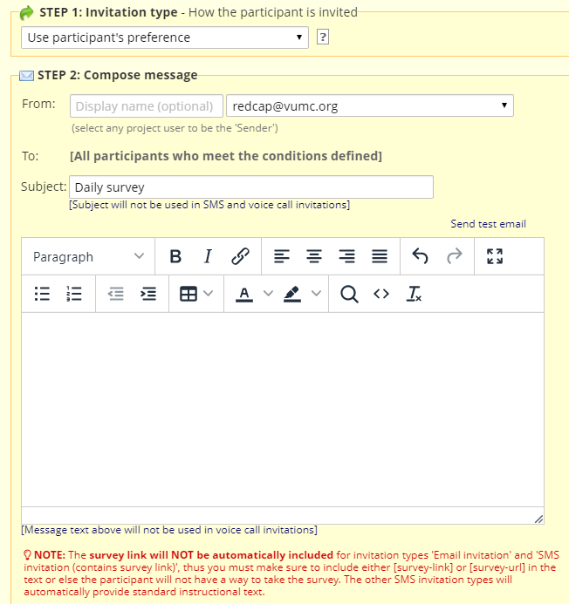

It is best to keep your message very brief – the cell phone carrier may break up the message into separate texts if the message length is too long and it’s possible the texts may arrive out of order, like the image on the following page:
So consider only providing the survey link and a few words about it. Any further instructions can be included in the Survey Instructions which you set via Survey Settings.

Stop Logic in Automated Invitations
It is highly recommended that you include ‘stop logic’ in the conditional logic section of Step 3 in an Automated Invitation. With that in place, REDCap will automatically cancel any future schedule invitations, should the participant no longer need to receive them. This is particularly relevant if you think your participant may withdraw from a study or become ineligible in some way.

The 'stop logic' could be a complex set of conditional logic, or it could be as simple as a single field in the project (i.e., the kill switch). For example, if you are wanting a survey invitation to be scheduled when a participant is at least 18 years old, your logic might be '[age] >= 18'. And if you want to add the 'stop logic' to be able to manually delete a scheduled invitation, you could have '[age] >= 18 and [remove_alert] <> 1', in which the field 'remove alert' is a Yes/No field. So in this instance, if you wanted to have the scheduled invitation deleted, you could simply go to the data entry form where the 'remove alert' field is located, and set it to 'Yes'. This can be done a variety of different ways. This is merely a simple example to introduce this concept. Remember, the key to using 'stop logic' is that the 'ensure logic is still true' checkbox MUST be checked.

Datediff/today calculations in Automated Invitations
Please note, if you are using conditional logic to send a survey invitation and it contains a datediff/today calculation, the future invitation will not display on the Survey Invitation Log. That is because the invitation does not display until it has been scheduled. And technically the condition for a datediff/today calculation hasn’t been met yet. So it will only show up on the day that condition has been met.

Alerts & Notifications
You can create an Alert via the Alerts & Notifications application to send a text or voice call to a participant.

Setting up your project to use Twilio in Alerts & Notifications
To have the ability to use Twilio via the Alerts & Notifications application, you will need to change a setting on the Project Setup page. On that page, click on the ‘Configure Twilio Settings’ button (in the Twilio SMS and Voice Call services section). For the second setting, Select the project modules in which the Twilio service will be enabled, click the drop-down arrow (see image below):
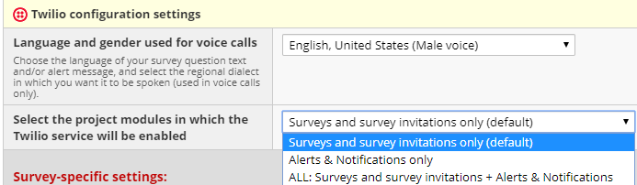

The setting defaults to ‘Surveys and survey invitations only”. You will need to change it to one of the other options that includes Alerts.

To create an Alert that uses Twilio
You can create the Alert just as you would any other alert. However, now you will have the option in Step 3 to send the alert as an SMS Text Message or a Voice Call:
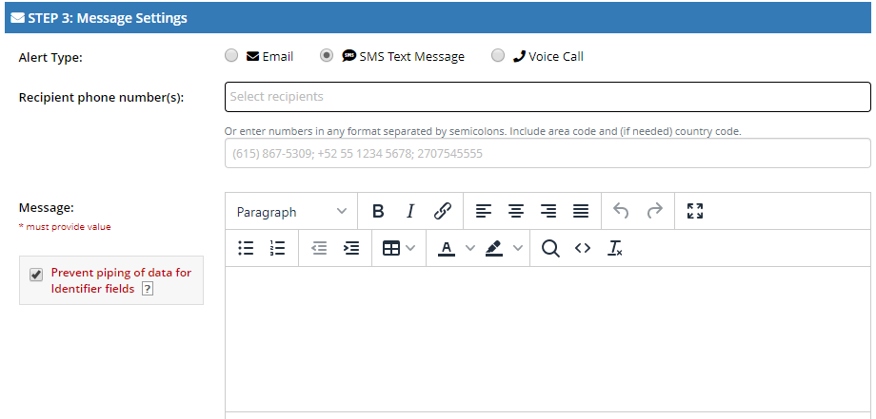

You will note that you can click on the ‘Select Recipients’ drop-down list to see a list of users and phone-validated fields on the project. Additionally, there is a box where you can manually enter a phone number.

Also note that there is no subject line for the message.

It is best to keep your message very brief – the cell phone carrier may break up the message into separate texts if the message length is too long and it’s possible the texts may arrive out of order, like the image on the following page:
If providing a survey link, consider only providing the survey link and a few words about it. Any further instructions can be included in the Survey Instructions which you set via Survey Settings.

Stop Logic in Alerts

It is highly recommended that you include ‘stop logic’ in the conditional logic section of Step 1 in an Alert. With that in place, REDCap will automatically cancel any future scheduled alerts, should the participant no longer need to receive them. This is particularly relevant if you think your participant may withdraw from a study or become ineligible in some way.

The 'stop logic' could be a complex set of conditional logic, or it could be as simple as a single field in the project (i.e., the kill switch). For example, if you are wanting to schedule an alert when a participant is at least 18 years old, your logic might be '[age] >= 18'. And if you want to add the 'stop logic' to be able to manually delete a scheduled alert, you could have '[age] >= 18 and [remove_alert] <> 1', in which the field 'remove alert' is a Yes/No field. So in this instance, if you wanted to have the scheduled alert deleted, you could simply go to the data entry form where the 'remove alert' field is located, and set it to 'Yes'. This can be done a variety of different ways. This is merely a simple example to introduce this concept. Remember, the key to using 'stop logic' is that the 'ensure logic is still true' checkbox MUST be checked.

The stop logic feature is something that a user on a project can manage (by marking the stop logic field on a project) or you can set it up so that the participant has the ability to opt-out.

Participant-driven opt-out
You can create language in the text message invite offering an opt-out method for participants who may be receiving automated invites unnecessarily.
This can be accomplished by the participant responding to the SMS survey invite with the word "Stop". All future invites will be halted from reaching the participants device although automated invites will still attempt to send until the participants number is removed from the project

Checking the Notification Log for past and future alerts
You can go to the Alerts & Notification application and click on the Notification Log to see past alerts that were triggered and also future alerts that are scheduled.

Datediff/Today calculations in Alerts
Please note, if you are using conditional logic to send an alert and it contains a datediff/today calculation, the future invitation will not display on the Notification Log. That is because the alert does not display until it has been scheduled. And technically the condition for a datediff/today calculation hasn’t been met yet. So it will only show up on the day that condition has been met.

Message design and content tips

Line breaks
Beware that REDCap removes all line breaks in messages. So the text you send in a message will come across all together, without line or paragraph breaks.

So this message:
How are you feeling today?
1,Excellent
2,Good
3,Fair
4,Okay
5,Poor

Will look like this:
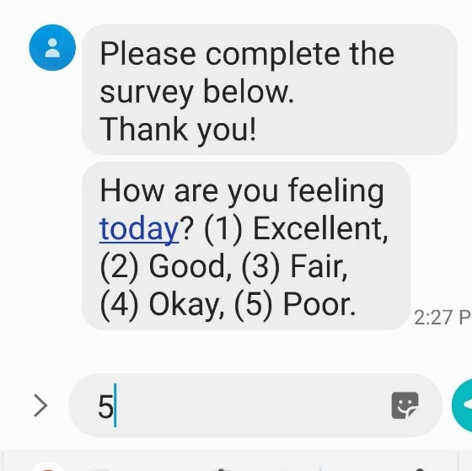

Character limits
Each text message (messages, survey invitations and survey questions, if applicable) is limited to 160 characters. Keep in mind that smart variables of survey links translate into the actual survey link, which will be many characters longer than the smart variable.

It is best to keep your message very brief – the cell phone carrier may break up the message into separate texts if the message length is too long and it’s possible the texts may arrive out of order, like the image on the following page:
So if sending a survey link, consider only providing the survey link and a few words about it. Any further instructions can be included in the Survey Instructions which you set via Survey Settings.

Message content limitations
On April 9, 2020 we were notified that when using Twilio to send SMS messages/survey invitations, some mobile carriers are blocking texts containing the word "COVID". We are not yet sure which specific carriers are doing the blocking.

Carrier Filtering
Some cell phone carriers filter SMS messages. Please consult Twilio’s Help Center for more information about what that is, how it works and what you might need to do to ensure your SMS messages get through to your participant. You can find an article on that topic here.

Project Management tips

Change in participant phone number
If a participant’s phone number changes in the middle of a study, you will need to update it in the project.

If using the Participant List…
Go to the Participant list and edit the number there. It will update the phone number for all upcoming surveys.

If using a phone-validated number field…
Navigate to that field in the project and edit the phone number in that field. The previous phone number will be stored via the Data History widget.

Longitudinal Projects
If you are using Twilio in a longitudinal project, as always, you will need to prepend any variable name or smart variable name with the event name. You can find the event name by going to the Project Setup page and clicking on the Define My Events button (in the Define your events and designate instruments for them’ section):

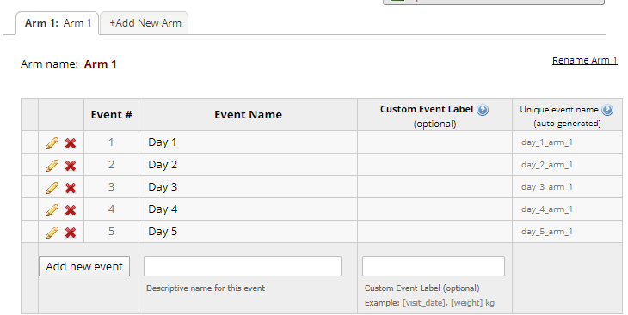

The string of text in the ‘Unique event name’ column is the text you need to write in square brackets and place before the variable name. This way, REDCap knows exactly which event you are referencing for that variable.

Overlapping messages
When designing your project, keep in mind what the experience will be like for the recipient, particularly if they are to receive several messages/calls in the same day. For instance, if they are sent the same survey 3 times a day, you might want to make it very clear how the three messages are different.

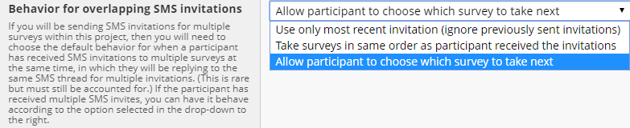

Troubleshooting errors
REDCap will log the invitations it has sent out via the Survey Invitation Log. The below image demonstrates what you might see if there are Twilio errors. Note the far right column with the header “Errors (if any)”. You see these errors: "ERROR SENDING SMS" and "ERROR MAKING VOICE CALL"
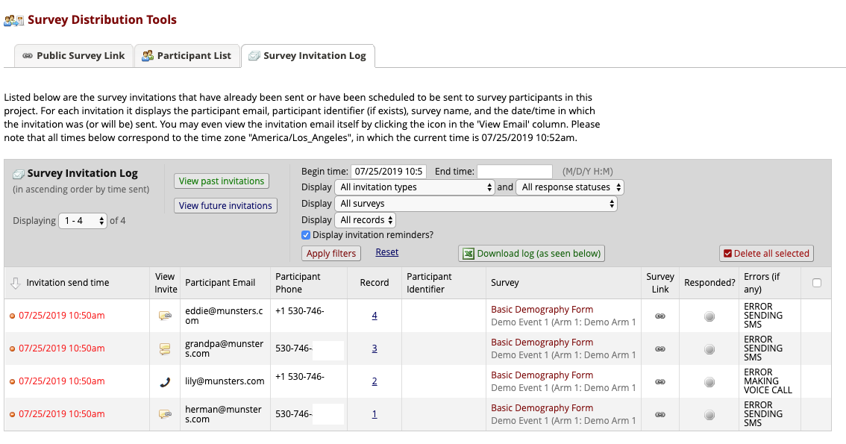
Those errors indicate that REDCap received an error from Twilio when attempting to send the SMS or make the voice call. This might happen if you're using a test/sandbox Twilio account, if your Twilio account runs out of money, or if the phone number is somehow not correct or not formatted properly.

You might consider looking at Twilio's error logs in your account to see if it provides a description of that error.

Incoming messages from participants
If a participant replies to a Twilio text with anything other than a response to a question, the content of their text does not get stored anywhere. This is because Twilio does not store logs of any of the messaging and there is not a place to capture/store a non-quantitative response from a participant in a REDCap project.

Best practices/Tips

Testing
It’s extremely important to test the Twilio feature before using it with participants. Test out the different delivery methods to see how it will look to the participant and determine which method will work best for your project.

For instance, if your participant is answering survey questions by replying to your Twilio text message, this is how it will appear to them:

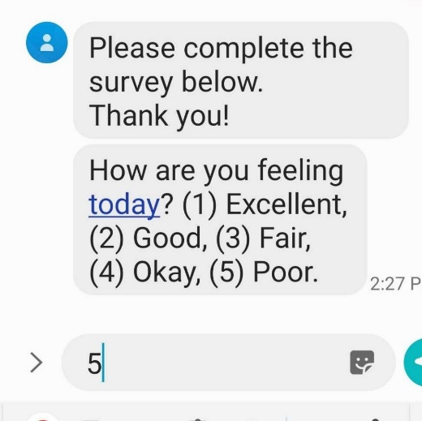

From seeing that test message, you might consider adding in additional instructions so that the participant knows to enter the corresponding number.

It’s also a good idea to test your project on different cell phone carriers. You could poll your study team to find out their different cell phone carriers. And then test messaging with their phone numbers, noting any differences as to how the message looks according to which carrier a person has.

It is best to keep your message very brief – the cell phone carrier may break up the message into separate texts if the message length is too long and it’s possible the texts may arrive out of order, like the image on the following page:
So if you include a survey link, consider only providing the survey link and a few words about it. Any further instructions can be included in the Survey Instructions which you set via Survey Settings.

Twilio Registry
Twilio now allows you to create a business profile which can be assessed by a third party. Your profile will receive a Trust Score. If your Trust Score is medium or high, it is less likely your messages will be filtered by carriers (e.g. they won’t think it’s spam). You can read more about this in the following Twilio support article:

https://support.twilio.com/hc/en-us/articles/1260803225669-Message-throughput-MPS-and-Trust-Scores-for-A2P-10DLC-in-the-US

So you might register your business profile to earn a trust score to increase the likelihood of your messages getting to your recipients.

Fully complete any survey invitations that you send to your own cell phone
If you send an invitation to begin a survey via SMS Conversation, REDCap notes that the survey has begun if you respond back the first time and it will remember that process in the survey (to know which question you’re on). If you don’t complete that first SMS survey and then you send another invitation (which might be another SMS Conversation type or possibly another type – e.g. SMS w/ survey link), then REDCap’s progress tracking for the participant’s cell phone number gets muddled a bit and REDCap gets confused about what to do. And so it ends up thinking that you’re not done with the previous survey while simultaneously trying to perform actions for the new invitation that was sent to you too. So the SMS messages get doubled up, and when you respond to one, it thinks you’re responding to it and the other and gives the participant the error message about entering the wrong value, for instance.

Ask your participants to add the Twilio number to their phone’s address book
Tell your participants the phone number from which they will receive texts (the Twilio phone number you purchased). Ask them to add that phone number to their phone’s address book.

Reasoning
Initial messages seem to go through to all participants but repeated weekly or daily messages containing links and repetitive text that the respondent does not interact with via SMS (i.e., messages with links, respondent only interacts with the link) seem to get blocked around the fifth (approximate) repeated instance. Having the respondent add the Twilio Study Phone number to their contacts list "unblocked" the messages and new messages went through to the cell phone. We have anecdotal evidence this is limited to iPhone cell phones (carriers were Sprint and T-Mobile but possibly all carriers).

Advising your participant that charges may apply
Depending on the participant’s cell phone plan, they may be charged for texts they receive (and send, if applicable). You might consider advising the participants of this.

Asking participants to confirm that they agree to be contacted by text or phone

You might consider adding a field that says, ‘I agree to be contacted by text or phone’ and have the participant answer that question. Then you have evidence in your project that the participant is consenting to being contacted by phone.

Carrier Filtering
Be aware that some cell phone carriers filter SMS messages. Please consult Twilio’s Help Center for more information about what that is, how it works and what you might need to do to ensure your SMS messages get through to your participant. You can find an article on that topic here.

Checking Survey Invitation Log/Notification Log
To verify that your messages are being scheduled as expected, you can check the Survey Invitation log or, if using Alerts & Notifications, the Notification Log. Some users make it a practice to check the log on a regular basis, to make sure invitations/messages are going out as expected.

How Twilio and REDCap work together
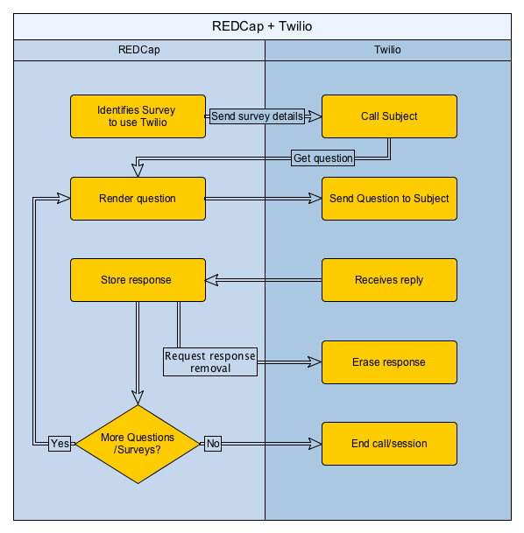

SMS Regulatory Guidelines and best practices
Twilio offers a summary of regulatory guidelines for each country. To see the summary for the US, check here. (You can change click on the ‘back to guidelines’ link to change it to a different country.

Security
- In order to make sure that no REDCap data is ever stored on the Twilio servers, it is up to the REDCap user to disable Twilio’s Request Inspector. The Request Inspector is a tool provided by Twilio that lists all requests made between Twilio and an external application.
- With the Request Inspector disabled, the only data that Twilio retains is metadata about SMS messages and calls, and this data is scrubbed by a cron job that REDCap runs every 120 seconds. (Cron is standard software on Linux-based computers that allows for the scheduled execution of software-defined tasks that can be repeated).
- Twilio provides specific HTTP headers that are encoded and are verifiable to ensure that they are truly coming from the Twilio server, which is further corroborated by the following Twilio API reference: https://www.twilio.com/docs/api/security#validating-requests .
- Relevant whitepaper from the Twilo Support team: Ensuring HIPAA compliancy with Twilio-made applications: https://support.twilio.com/hc/en-us/articles/223136467-Ensuring-HIPAA-compliancy-with-Twilio-made-applications
- Relevant whitepaper on Twilio Security: https://s3.amazonaws.com/ahoy-assets.twilio.com/Whitepapers/Twilio_Whitepaper_Security-Architecture.pdf
- White paper regarding the HIPAA conduit exception rule: http://www.healthcarebusinesstech.com/hipaa-conduit-exception-rule/

Authentication
- REDCap uses the Twilio API to issue a request to Twilio (over TLS) from a project using the AuthToken and the project-specific SID and phone number. Credentials are sent using HTTP authentication.
- Twilio sends an HTTP POST to REDCap’s RESTful web service without HTTP authentication but with arguments.
- REDCap validates both that the POST has come from Twilio and is for a particular project (SID/phone number). This is done by taking the POST arguments, prepending the URL that had been given to Twilio to use when sending a POST to REDCap, signing the result using the AuthToken, base64 encoding the resulting hash, and comparing the signature to an X-Twilio-Signature header that's passed in the POST request.

Risk Assessment
 | Item | Risk | Risk Level | Mitigating Factors
1 | RC initiates survey as voice call | Exposure of voice to text response data on Twilio servers | Low | It is possible to disallow persistent storage of PHI on Twilio servers. REDCap also uses a cron job to delete metadata every 120 seconds.
2 | RC conducts survey via SMS conversation | PHI in SMS conversation (potential exposure to SMS provider and others) | High
3 | RC sends survey invitation link via SMS | The link is exposed/invitation goes to the wrong participant | Low | Does not expose PHI.
4 | RC sends survey invitation via SMS to take survey as voice call (respondent makes call) | The link is exposed/invitation goes to the wrong participant | Low | Does not expose PHI.
 |  | Exposure of voice to text response data on Twilio servers | Low | It is possible to disallow persistent storage of PHI on Twilio servers. REDCap also uses a cron job to delete metadata every 120 seconds.
5 | RC sends survey invitation via SMS to take survey as voice call (respondent receives call) | The link is exposed/invitation goes to the wrong participant | Low | Does not expose PHI.
 |  | Exposure of voice to text response data on Twilio servers | Low | It is possible to disallow persistent storage of PHI on Twilio servers. REDCap also uses a cron job to delete metadata every 120 seconds.
6 | Communication between REDCap and Twilio | Exploitation of REDCap’s RESTful web service from non-Twilio sources | Low | REDCap validates POST requests from Twilio over TLS and ensures that the POST is for a particular SID/phone number.
 |  | The user’s Twilio credentials are compromised. An adversary accesses the Twilio account and intercepts PHI there. | Medium | Twilio allows 2-factor authentication. It is possible to disallow persistent storage of PHI on Twilio servers. REDCap also uses a cron job to delete metadata every 120 seconds.
 |  | Traffic between Twilio and REDCap is not secured | Low | Twilio uses TLS to encrypt the communication channel.
7 | REDCap Twilio module | Software security of the module | Low | The REDCap development team created and vetted the security of the module.
8 | Survey questions | Exposure of PHI in a dynamically generated survey question based on a previous answer | Low | This only has the potential of exposing a survey participant’s PHI to the participant (and is not specific to Twilio).
9 | Voice calls | PHI is exposed during transit, e.g. in VoIP | Medium | Depends on the technology used for voice calls. End to end security is not within administrator’s control.
10 | Use of mobile device | PHI exposed orally by survey participant. Likelihood of participants taking surveys in a relatively public location higher with a mobile device. | High
11 | Authenticating REDCap to Twilio server | HTTP Auth is not enabled | Medium | 1. While enabling HTTP Auth allows the Twilio server to use a REDCap account to authenticate REDcap, it also exposes REDCap to attacks from Twilio.  2. Requires modifying REDCap source code, which is undesirable.

